

Church of St. John the Evangelist

SUNDAY AFTER

ASCENSION

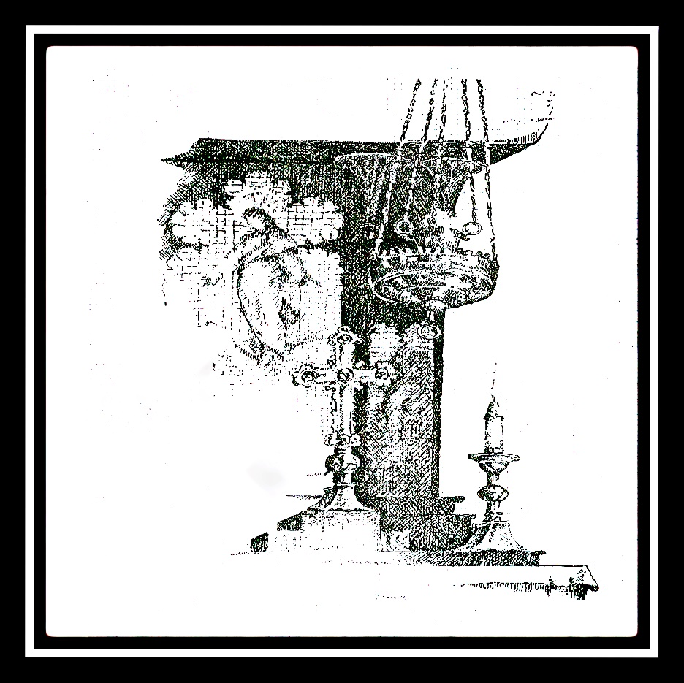

**May 21, 2023**

**SUNDAYS Matins 9:45 10:30 am High Mass**

**Weekday Mass Tuesday (en français), Thursday 5:45 pm, Saturday 12 Noon**

**Tuesdays 7:30 pm ZOOM Compline & Conversation**

Order of service for High Mass (page 3)

Upcoming Services (page 2) Prayer List (page 11)

About St. John’s (back cover)



**SERVICES AT THE REDROOF**

**GRIEVE, THEN GET GOING:**

**A NEW LOCATION ~ FRESH OPPORTUNITIES ~ SUSTAINABLE TRADITIONS**

**SUNDAYS 9:45 Matins 10:30 am**  **High Mass In church**

**Tuesdays 7:30 p.m. Compline & Conversation ZOOM**

**Friday 7:00 p.m. sept à huit Bible Study ZOOM**

Permanent Zoom link:[**https://zoom.us/j/332912007**](https://zoom.us/j/332912007)

(or by phone **438-809-7799** Meeting ID: 332 912 007)

**WEEKDAY MASSES. TUESDAY 5:45 pm (en français) THURSDAY 5:45 pm**

**SATURDAY 12 NOON In Church**

***Monday to Friday Holy Eucharist at Christ Church Cathedral 12:15***

**LITURGICAL ALERTS**

**WHITSUNDAY May 28 *High Mass 10:30 am***

**Monday & Tuesday after Pentecost *Mass 5:45 pm***

For those visiting for the first time, welcome to St. John the Evangelist! And for our parishioners returning to worship in the church, welcome back!

* The **bathroom** is located in the hallway to the left, through the door at the back of the church.

***Church Yard clean-up***

***On Saturday, 3rd June, from 12:30****, the Guild of Saint Jude is organizing a general clean up and revamping of the church premises which will include getting rid of trash, reorganizing flowerbeds, painting over graffiti, etc.*

*We are in need of volunteers, amongst other things to help us out. The more volunteers, the easier the task will be and the faster it will be done.*

*People should come with plastic gloves. The church will provide garbage bags, paint and paint brushes.*

*If you want to donate and plant flowers in the flowerbeds, you may also do it.*

*Please talk to* ***Fr Marc-Philippe*** *if you are interested in taking part in this project.* ***Merci/Thankyou***

**AN ORDER OF SERVICE - HIGH MASS**

**Sunday, May 21, 2023- 10:30 am**

**Organ Prelude.**Chorale-prelude on *Jesus Christus, unser Heiland*, BWV 665, by J. S. Bach (1685-1750)

**The Introductory Rite Mass setting:** *Communion Service* by J. Merbecke (1505-1585)

*The people stand at the sound of the bell.* **Cantor.** Carole LeDez

**Opening Hymn. # 424** - *King of Glory, King of Peace* - GWALCHMAI

**THE LITURGY OF THE WORD**

**The Introductory Rite**

**Introit.**

***Antiphon****. Consider, O Lord, and hear me, when I cry unto thee, alleluia:* ***unto thee my heart hath said, Thy Face, Lord, have I sought****; thy face, Lord, will I seek:* ***O hide not thou thy face from thy servant, alleluia, alleluia*.** Psalm. *The Lord is my light, and my salvation:* ***whom then shall I fear?*** Glory be..*.* ***Repeat antiphon.***

*Priest.* Let us pray. *The people kneel.*

*Priest.* Our Father who art in heaven hallowed by thy name; thy kingdom come; thy will be done, on earth as it is in heaven. Give us this day our daily bread; and forgive us our trespasses, as we forgive them that trespass against us; and lead us not into temptation, but deliver us from evil. **Amen.**

*Priest.* Almighty God, unto whom all hearts be open, all desires known, and from whom no secrets are hid: Cleanse the thoughts of our hearts by the inspiration of thy Holy Spirit, that we may perfectly love thee, and worthily magnify thy holy Name; through Christ our Lord. **Amen.**

*Deacon.* Our Lord Jesus Christ said: Hear O Israel, The Lord our God is one Lord; and thou shalt love the Lord thy God with all thy heart, and with all thy soul, and with all thy mind, and with all thy strength. This is the first and great commandment. And the second is like unto it: Thou shalt love thy neighbour as thyself. On these two commandments hang all the Law and the Prophets.

*People.* **Lord, have mercy upon us, and write both these thy laws in our hearts, we beseech thee.**

**Kyrie eleison.**

**Kyrie eleison. Christe eleison. Kyrie eleison.**

**Gloria in Excelsis.**

Glory be to God on high, and in earth peace, good will towards men. We praise thee, we bless thee, we worship thee, we glorify thee. We give thanks to thee for thy great glory, O Lord God, heavenly king, God the Father Almighty. O Lord, the only begotten Son, Jesu Christ, O Lord God, Lamb of God, Son of the Father, that takest away the sin of the world, have mercy upon us. Thou that takest away the sin of the world, receive our prayer. Thou that sittest at the right hand of God the Father, have mercy upon us. For thou only art holy, thou only art the Lord; thou only O Christ, with the Holy Ghost, art most high in the glory of God the Father. Amen.

**The Collects of the Day**

*Priest.* The Lord be with you.

*People.* **And with thy spirit.**

*Priest.* Let us pray.

O GOD the King of Glory, who hast exalted thine only Son Jesus Christ with great triumph unto thy kingdom in heaven: We beseech thee, leave us not comfortless; but send to us thine Holy Ghost to comfort us, and exalt us unto the same place whither our Saviour Christ is gone before; who liveth and reigneth with thee and the Holy Ghost, one God, world without end. **Amen.**

GRANT, we beseech thee, Almighty God, that like as we do believe thy only-begotten Son our Lord, Jesus Christ to have ascended into the heavens; so we may also in heart and mind thither ascend, and with him continually dwell; who liveth and reigneth with thee and the Holy Spirit, one God, world without end. **Amen.**

**The Lessons**

**The First Lesson**  ***2 Kings 2:9-15***

And it came to pass, when they were gone over, that Elijah said unto Elisha, Ask what I shall do for thee, before I be taken away from thee. And Elisha said, I pray thee, let a double portion of thy spirit be upon me. And he said, Thou hast asked a hard thing: nevertheless, if thou see me when I am taken from thee, it shall be so unto thee; but if not, it shall not be so. And it came to pass, as they still went on, and talked, that, behold, there appeared a chariot of fire, and horses of fire, and parted them both asunder; and Elijah went up by a whirlwind into heaven. And Elisha saw it, and he cried, My father, my father, the chariot of Israel, and the horsemen thereof. And he saw him no more: and he took hold of his own clothes, and rent them in two pieces. He took up also the mantle of Elijah that fell from him, and went back, and stood by the bank of Jordan; and he took the mantle of Elijah that fell from him, and smote the waters, and said, Where is the Lord God of Elijah? and when he also had smitten the waters, they parted hither and thither: and Elisha went over. And when the sons of the prophets which were to view at Jericho saw him, they said, The spirit of Elijah doth rest on Elisha. And they came to meet him, and bowed themselves to the ground before him.

**First Alleluia.**

*Alleluia. Alleluia. God reigneth over the heathen:* ***God sitteth upon his holy seat.* Alleluia**

**The Epistle**  ***1 St. Peter 4: 7-11***

The end of all things is at hand; be ye therefore sober, and watch unto prayer. And above all things have fervent charity among yourselves: for charity shall cover the multitude of sins. Use hospitality one to another without grudging. As every man hath received the gift, even so minister the same one to another, as good stewards of the manifold grace of God. If any man speak, let him speak as the oracles of God: if any man minister, let him do it as of the ability which God giveth; that God in all things may be glorified through Jesus Christ, to whom be praise and dominion forever and ever. Amen.

**Second Alleluia.** *The people stand.*

*Alleluia, Alleluia. I will not leave you comfortless****: I go away and come again unto you, and your heart shall rejoice. Alleluia***

**The Gospel** *St. John 15: 26-16.4*

*Deacon.* The Lord be with you.

*People.* **And with thy spirit.**

*Deacon****.***The Holy Gospel is written in the fifteenth chapter of the Gospel according to Saint John, beginning at the twenty-sixth verse.

*People.* **Glory be to thee, O Lord.**

And Jesus said unto his disciples, When the Comforter is come, whom I will send unto you from the Father, even the Spirit of truth, which proceedeth from the Father, he shall testify of me: and ye also shall bear witness, because ye have been with me from the beginning. These things have I spoken unto you, that ye should not be offended. They shall put you out of the synagogues: yea, the time cometh, that whosoever killeth you will think that he doeth God service. And these things will they do unto you, because they have not known the Father, nor me. But these things have I told you, that, when the time shall come, ye may remember that I told you of them

*People.* **Praise be to thee, O Christ.**

*Priest and people together.*

**I BELIEVE in one God the Father Almighty, Maker of heaven and earth, And of all things visible and invisible:**

**And in one Lord Jesus Christ, the only-begotten Son of God, Begotten of the Father before all worlds; God, of God; Light, of Light; Very God, of very God; Begotten, not made; Being of one substance with the Father; Through whom all things were made: Who for us men and for our salvation came down from heaven, And was incarnate by the Holy Ghost of the Virgin Mary, And was made man, And was crucified also for us under Pontius Pilate. He suffered and was buried, And the third day he rose again according to the Scriptures, And ascended into heaven, And sitteth on the right hand of the Father. And he shall come again with glory to judge both the quick and the dead: Whose kingdom shall have no end.**

**And I believe in the Holy Ghost, The Lord, The Giver of Life, Who proceedeth from the Father and the Son, Who with the Father and the Son together is worshipped and glorified, Who spake by the Prophets. And I believe One, Holy, Catholic, and Apostolic Church. I acknowledge one Baptism for the remission of sins. And I look for the Resurrection of the dead, And the Life of the world to come. Amen.**

**The Sermon** *Father Marc-Philippe Vincent*

**The Liturgy of the Eucharist**

**The Offertory**

**Offertory Verse.**

*God is gone up with a merry noise:* ***and the Lord with the sound of the trump, alleluia.***

***Offertory Hymn. #* 470** - *Praise my Soul the King of Heaven* - PRAISE MY SOUL

**Offertory.** Aria "Mein Jesus hat nunmehr" from Cantata *Gott fähret auf mit Jauchzen*, BWV 43.

Carole LeDez, soprano.

*Priest.* Pray that my sacrifice and yours may be acceptable to God, the almighty Father.

*People.* **May the Lord receive this sacrifice at thy hands, to the praise and glory of his Name, to our benefit, and to that of all his holy Church.**

**The Intercessions**

*Deacon.* Let us pray.

*The deacon offers the biddings. After praying for the departed, the deacon says:*

Rest eternal grant unto them, O Lord, and let light perpetual shine upon them. **Amen.** Gathering together all our intercessions we entrust them to the prayer of Our Lady, Hail Mary, full of grace, the Lord is with thee. Blessed art thou among women, and blessed is the fruit of thy womb, Jesus.

*People.***Holy Mary, Mother of God, pray for us sinners now and at the hour of our death. Amen**

*The people kneel.*

*Priest.* Almighty and everliving God, who by thy holy Apostle hast taught us to make prayers and supplications, and to give thanks for all men: we humbly beseech thee most mercifully to accept our alms and oblations, and to receive these our prayers, which we offer unto thy divine Majesty; beseeching thee to inspire continually the universal Church with the spirit of truth, unity, and concord: And grant that all they that do confess thy holy Name may agree in the truth of thy holy word, and live in unity and godly love.

We beseech thee also to lead all nations in the way of righteousness; and to guide and direct their governors and rulers, that thy people may enjoy the blessings of freedom and peace: And grant unto thy servant *CHARLES* our King and to all that are put in authority under him, that they may truly and impartially administer justice, to the maintenance of thy true religion and virtue.

Give grace, O heavenly Father, to all Bishops, Priests, and Deacons, and specially to thy servant *MARY* our bishop, *LINDA* our primate, and *JUSTIN*, Archbishop of Canterbury, that they may both by their life and doctrine set forth thy true and living Word, and rightly and duly administer thy holy sacraments.

Prosper, we pray thee, all those who proclaim the gospel of thy kingdom among the nations: And to all thy people give thy heavenly grace, and specially to this congregation here present, that, with meek heart and due reverence, they may hear and receive thy holy Word; truly serving thee in holiness and righteousness all the days of their life.

And we most humbly beseech thee of thy goodness, O Lord, to comfort and succour all them who in this transitory life are in trouble, sorrow, need, sickness, or any other adversity, especially those for whom our prayers are desired.

We remember before thee, O Lord, all thy servants departed this life in thy faith and fear: and we bless thy holy Name for all who in life and death have glorified thee; especially the ever-Blessed Virgin Mary, Blessed John the Evangelist our Patron, St Joseph; St Patrick and all thy saints, beseeching thee to give us grace that, rejoicing in their fellowship, we may follow their good examples, and with them be partakers of thy heavenly kingdom.

Grant this, O Father, for Jesus Christ’s sake, our only Mediator and Advocate, to whom, with thee and the Holy Ghost, be all honour and glory, world without end. **Amen.**

**The Confession and Absolution**

*Deacon.* Ye that do truly and earnestly repent you of your sins, and are in love and charity with your neighbours, and intend to lead the new life, following the commandments of God, and walking from henceforth in his holy ways: Draw near with faith, and take this holy Sacrament to your comfort; and make your humble confession to Almighty God, meekly kneeling upon your knees.

*Priest and people together.* **ALMIGHTY GOD, Father of our Lord Jesus Christ, maker of all things, judge of all men: we acknowledge and confess our manifold sins and wickedness, which we from time to time most grievously have committed, by thought, word, and deed, against thy Divine Majesty. We do earnestly repent, and are heartily sorry for these our misdoings. Have mercy upon us, most merciful Father; for thy Son our Lord Jesus Christ’s sake, forgive us all that is past; and grant that we may ever hereafter serve and please thee in newness of life, to the honour and glory of thy Name; Through Jesus Christ our Lord. Amen.**

*Priest.* Almighty God, our heavenly Father, who of his great mercy hath promised forgiveness of sins to all them that with hearty repentance and true faith turn unto him: Have mercy upon you; pardon and deliver you from all your sins; confirm and strengthen you in all goodness; and bring you to everlasting life; through Jesus Christ our Lord. **Amen.**

*Deacon.* Hear what comfortable words our Saviour Christ saith unto all that truly turn to him.

Come unto me all that labour and are heavy laden, and I will refresh you. *Matthew 11:28*

God so loved the world, that he gave his only-begotten Son, to the end that allthat believe in him should not perish,but have eternal life. *John 3:16*

*Deacon.* Hear also what Saint Paul saith.This is a true saying, and worthy of all men to be received, that Christ Jesuscame into the world to save sinners. *1 Timothy 1:15*

*Deacon.* Hear also what Saint John saith. *I*f any man sin, we have an Advocate with the Father, Jesus Christ the righteous;and he is the propitiation for our sins. *1 John 2:1-2*

**The Eucharistic Prayer**

*Priest.* The Lord be with you;

*People.***And with thy spirit.**

*Priest.* Lift up your hearts;

*People.* **We lift them up unto the Lord.**

*Priest.* Let us give thanks unto our Lord God;

*People.***It is meet and right so to do.**

*Priest.* It is very meet, right, and our bounden duty, that we should at all times, and in all places give thanks unto thee, O Lord, Holy Father, Almighty, Everlasting God, Creator and Preserver of all things.

THROUGH thy most dearly beloved Son Jesus Christ our Lord; who after his most glorious Resurrection manifestly appeared to all his Apostles, and in their sight ascended up into heaven to prepare a place for us; that where he is, thither we might also ascend, and reign with him in glory.

THEREFORE with Angels and Archangels and all the company of heaven, we laud and magnify thy glorious Name; evermore praising thee, and saying:

**Sanctus and Benedictus.**

**HOLY, HOLY HOLY, Lord God of Hosts. Heaven and earth are full of thy glory. Glory be to thee O Lord most high. Blessed is he that cometh in the name of the Lord: Hosanna in the highest.**

**The Consecration**

*Priest.* BLESSING and glory and thanksgiving be unto thee Almighty God, our heavenly Father, who of thy tender mercy didst give thine only Son Jesus Christ to take our nature upon him, and to suffer death upon the Cross for our redemption; who made there, by his one oblation of himself once offered, a full, perfect, and sufficient sacrifice, oblation, and satisfaction, for the sins of the whole world; and did institute, and in his holy Gospel command us to continue, a perpetual memorial of that his precious death, until his coming again.

Hear us, O merciful Father, we most humbly beseech thee; and of thy almighty goodness vouchsafe to bless, hallow and sanctify, with thy word and Holy Spirit, these holy gifts, and grant that we receiving these thy creatures of bread and wine, according to thy Son our Saviour Jesus Christ's holy institution, in remembrance of his death and passion may be partakers of his most blessed Body and Blood;

who, in the same night that he was betrayed, took Bread; and, when he had given thanks, he brake it; and gave it to his disciples, saying, “Take, eat; this is my body which is given for you: do this in remembrance of me.”Likewise after supper he took the Cup; and, when he had given thanks, he gave it to them, saying, “Drink ye all, of this; for this is my blood of the New Covenant, which is shed for you and for many for the remission of sins: do this, as oft as ye shall drink it, in remembrance of me.”

Wherefore, O Father, Lord of heaven and earth, we thy humble servants, with all thy holy Church, remembering the precious death of thy beloved Son, his mighty resurrection, and glorious ascension at thy right hand whence he interceedeth perpetually for us, miserable sinners, and looking for his coming again in glory, do make before thee, in this sacrament of the holy Bread of eternal life and the Cup of everlasting salvation, the memorial which he hath commanded; And we entirely desire thy fatherly goodness mercifully to accept this our sacrifice of praise and thanksgiving, even as thou didst vouchsafe to accept the gifts of thy servant Abel, the Righteous, and the sacrifice of Abraham, our Patriarch: and the holy sacrifice of Melchisedech thy high priest as signs of the one and perfect sacrifice of Christ.

And we humbly beseech thee, Almighty God: command these offerings to be brought by the hands of thine Angel to thine altar on high, in the sight of thy divine majesty: And we most humbly beseech thee to grant, that by the merits and death of thy Son Jesus Christ, and through faith in his blood, we and all thy whole Church may obtain remission of our sins, and all other benefits of his passion; And we pray that by the power of thy Holy Spirit, all we who are partakers of this holy Communion may be fulfilled with thy grace and heavenly benediction; through Jesus Christ our Lord, by whom and with whom, and in whom, in the unity of the Holy Spirit, all honour and glory be unto thee, O Father Almighty, world without end. **Amen.**

*Priest.* And now, as our saviour Christ has taught us, we are bold to say.

*Priest and people together.* **OUR FATHER who art in heaven, hallowed be thy Name, thy kingdom come, thy will be done, on earth as it is in heaven. Give us this day our daily bread; and forgive us our trespasses, as we forgive them that trespass against us; and lead us not into temptation, but deliver us from evil. For thine is the kingdom, the power, and the glory, For ever and ever.**

*Priest.* The peace of the Lord be always with you;

*People.* **And with thy spirit.**

*Priest and people together.* **WE DO NOT PRESUME to come to this thy Table, O merciful Lord, Trusting in our own righteousness, But in thy manifold and great mercies. We are not worthy So much as to gather up the crumbs under thy Table. But thou art the same Lord, Whose property is always to have mercy: Grant us therefore, gracious Lord, So to eat the Flesh of thy dear Son Jesus Christ, And to drink his Blood, That our sinful bodies may be made clean by his Body, And our souls washed through his most precious Blood, And that we may evermore dwell in him, And he in us. Amen.**

**The Communion**

**Agnus Dei.**

O Lamb of God, that takest away the sin of the world, have mercy upon us. O Lamb of God, that takest away the sin of the world, have mercy upon us. O Lamb of God, that takest away the sin of the world, grant us thy peace.

*Priest*. Behold the Lamb of God, which taketh away the sin of the world.

**Communion Sentence.**

*Father, while I was with them in the world, I kept those that thou gavest me, alleluia:**and now I come to thee.* *I pray thee not that thou shouldest take them out of the world:* ***but that thou shouldest keep them from the evil, alleluia, alleluia.***

**Communion**.  Chorale-prelude on *Jesus Christus, unser Heiland*, BWV 666, by J. S. Bach

**Communion Hymn. *#* 147** *The head that once was crowned with thorns* - ST. MAGNUS

**The Concluding Rite**

*Priest.*Almighty and everliving God, we most heartily thank thee that thou dost graciously feed us, in these holy mysteries, with the spiritual food of the most precious Body and Blood of thy Son our Saviour Jesus Christ; assuring us thereby of thy favour and goodness towards us; and that we are living members of his mystical body, which is the blessed company of all faithful people; and are also heirs through hope of thy everlasting kingdom.

*Priest and people together.* **AND HERE** **we offer and present unto thee, O Lord, ourselves, our souls and bodies, to be a reasonable, holy, and living sacrifice unto thee. And although we are unworthy, yet we beseech thee to accept this our bounden duty and service, not weighing our merits, but pardoning our offences; through Jesus Christ our Lord, to whom, with thee and the Holy Ghost, be all honour and glory, world without end. Amen.**

*Priest****.*** Grant, we beseech thee, O Lord: that we who are filled with thy sacred gifts may ever continue in thanksgiving. Through Jesus Christ our Lord. Amen.

The Peace of God, which passeth all understanding, keep your hearts and minds in the knowledge and love of God, and of his Son Jesus Christ our Lord: and the blessing of God Almighty, the Father, the Son, and the Holy Ghost, be amongst you and remain with you always. **Amen.**

*Deacon.*Depart in peace. Alleluia

*People.* Thanks be to God. **Alleluia**.

**Closing Hymn. # 148** *The Lord Ascendeth up on high* - NUN FREUT EUCH

**Postlude.** Prelude in C major, BWV 545, by J. S. Bach

***REGINA CAELI***

Joy to thee, O Queen of Heaven**, alleluia**

He whom thou wast meet to bear, **alleluia**

As he promised hath arisen, **alleluia**

Pour for us to God thy prayer**, alleluia.**

Rejoice and be glad, O Virgin Mary, alleluia

**For the Lord is risen indeed, Alleluia!**

Let us Pray

O God, who by the resurrection of thy Son, our Lord Jesus Christ, hast given joy unto the world; grant we beseech thee, that aided by the prayers of his Mother, the Blessed Virgin Mary, we may obtain the joys of eternal life; through Jesus Christ our Lord. **Amen**

**Postlude.**



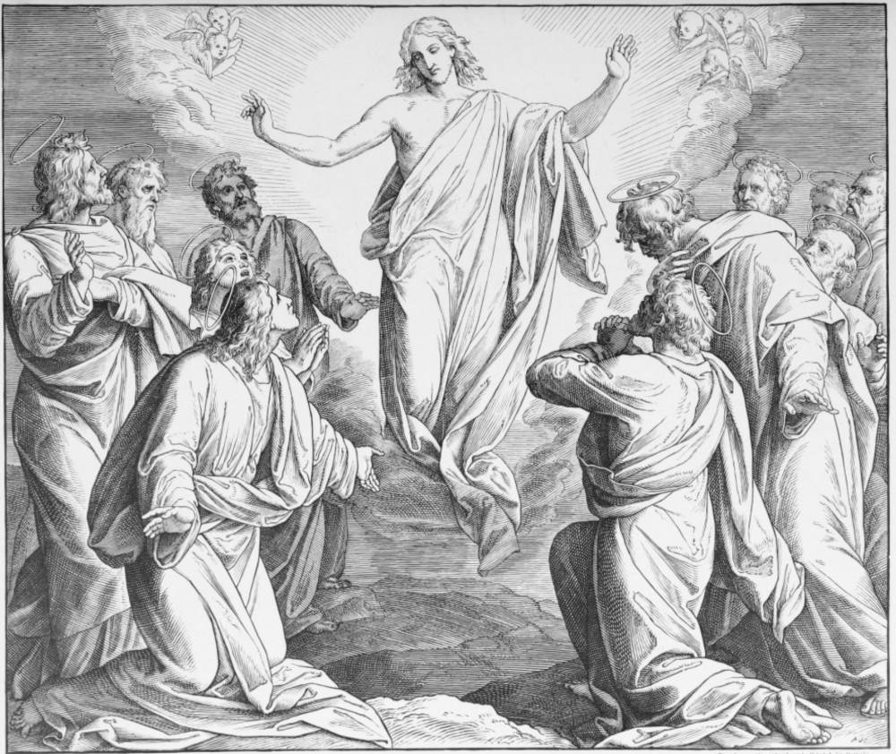

**Prayers of the People**

**In Faith, Hope and Charity let us pray for the good estate of the Catholic church.** *We give thanks for our collective health and resilience at this time. We continue to pray for all medical staff; hospitals and clinics.*  **We remember** *St. Michael and all Angels, Winnipeg; Our Diocesan prayer partners, The Territory of the People and the Diocese of Masasi; and the community of St. Michael’s Mission. For those who suffer injustice and those who work for justice and peace. We pray for the end of the conflict between Ukraine & Russia, for all the peoples of the world contending with extremism, violence and polarization. Let us pray for Canada’s Indigenous peoples; for our Earth and its living systems, and those suffering from natural and human caused disasters.* ***We also pray for our parish that we may continue as a community of faith.***

[***Anglican Cycle of Prayer (May 21-27)***](https://anglicancommunion.org/media/422641/acp_from-aba-to-zululand-2021-to-2023_web.pdf)

**Sun** The Church in the Province of the West Indies

**Mon** The Diocese of Taita-Taveta – The Anglican Church of Kenya

**Tues** The Diocese of Taiwan – The Episcopal Church (VIII (8) Province)

**Wed** The Diocese of Tamale – The Church of the Province of West Africa

**Thu** The Diocese of Tanga – The Anglican Church of Tanzania

**Fri** The Diocese of Central Tanganyika – The Anglican Church of Tanzania

**Sat** The Diocese of South West Tanganyika – The Anglican Church of Tanzania

[***Diocesan Cycle of Prayer***](https://static1.squarespace.com/static/53339102e4b00c509597c34c/t/6001f5b4514b6c73056efd5b/1610741172969/Prayer+Roster+2021.pdf)

**Sun** Mile-End Community Mission

**Mon** St Michael’s Mission

**Tues** Tyndale – St Georges Community Centre

**Wed** Anglican Church Women

**Thu** Crosstalk Ministries

**Fri** Lay Readers’ Association

**Sat** Lay Readers’ Association

**For those in special need:** Jim Best, Mildred Fletcher, Hallam Taylor, Scott Wood, Patricia Cerundolo

**For continuing support:**Marc & Josephine,Simon, Karen, Charles, Fr Richard Cawley, Jayne Demakos, Garrfield Du Couturier-Nichol, Diane, Tony Whitehead, Juanita Docherty-McFarlane, Ian MacLean, Vessella, Glenn Cartwright, Geraldine Doran, Desmond Murphy, Mike Curry, Tom Byford, Deirdre Hitchcox, Frances Kemp, Thomas Numann, Sandra Guillaume, Peter Iveson, RoseMary, Louise Driver, BB Gaylord, Hannah Brockow, Alexandra Belden, Anny Guillemette, Tania, Louis Angers, Carol von Bulow

***Commemorations (May 21-27)***

**Sun** Ian Pitt-Taylor, Gordon Smith-Loggie, Charles Clouston Porteous, Frank Hall, Roger Taylor (brother of

Charles) recently departed

**Mon**  Dorothy Morrow, William Sharkey, Frank Brown

**Tues** Lavina Holland, Mary McCall

**Wed** Beatrice Brown, Isobel MacFarlane, Edward Thomas, Lillian Herbert

**Thur** Dorothy Alderson, Kathleen Bentley

**Fri** David Henderson, Mary Hobson

**Sat**  William Dugan, Robert Ward, Mabel Bentley, Eric Bathurst, Louise Webb, Florence Smith

**THE CHURCH OF** **ST. JOHN THE EVANGELIST**

**At the cutting edge of Tradition & a resource for the wider Church**

Founded in 1861, St. John’s is a distinct and loving community in the heart of Montreal, centered around the Anglo-Catholic Eucharistic tradition. We are committed to serving God in ‘the beauty of holiness’ through ritual, word, and music.

‘Openness to all’ is a fundamental characteristic of the parish. Such openness brings together people from a broad spectrum of origins, opinions, and life experiences, making the congregation diverse, interesting, and stimulating.

We hope that your experience in our church brings you peace and joy.

**GIVING**

**Thank you** to all those who are giving so generously to St John’s in these difficult times. Your ongoing support is much appreciated. Although we are not all meeting as a congregation in the church, the ongoing running costs of St. John’s, **$850 per day**, continue. You can give by

a) Weekly Offering Envelopes,

b) PAR (Pre-authorized Remittance)

c) Canada Helps on our website [**www.redroof.ca**](http://www.redroof.ca)

d)  **E transfers. The Parish is now set up to accept E transfers for donations. Follow your banking institutions instructions and go to** [**office@redroof.ca**](mailto:office@redroof.ca)

**PROMENADE DES ARTISTES**

137 President Kennedy Avenue

Montreal (Quebec) H2X 3P6

redroof.mtl**

 **office@redroof.ca     514-288-4428**[**www.redroof.ca**](http://www.redroof.ca/)

**THE REV’D CANON KEITH A. SCHMIDT, RECTOR**

[**rector@redroof.ca**](mailto:rector@redroof.ca)514-717-4930 (Cell)  514-288-6130 (Study)

**Associate Priests:**The Rev’d Wendy H. Telfer - [thurifer@hotmail.com](mailto:thurifer@hotmail.com) - 514-506-2386

The Rev’d Marc-Philippe Vincent – [marc-philippe.vincent@redroof.ca](mailto:marc-philippe.vincent@redroof.ca) - 514-915-2067

**Assistant Curate:** The Rev’d Susan Searle - [inguz@sympatico.ca –](mailto:inguz@sympatico.ca%20-) 438-823-2106.

**Honorary Assistant:** The Rev’d Dr. Richard  Cawley, **Honorary Associate**: Captain the Rev’d Alain Brosseau

**Assistant Priest Emeritus**: The Rev’d Canon Dr. J. Simons

**Director of Music:**Dr Federico Andreoni

**Wardens:** Geoffrey Little and Sara Bohl Pistolesi