

Church of St. John the Evangelist

**THE FOURTH SUNDAY IN LENT**

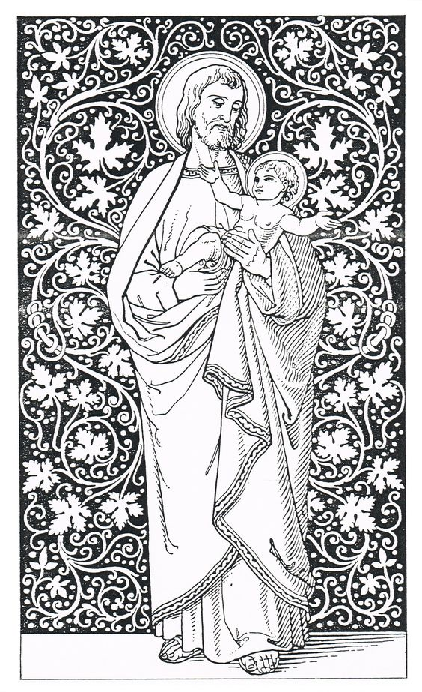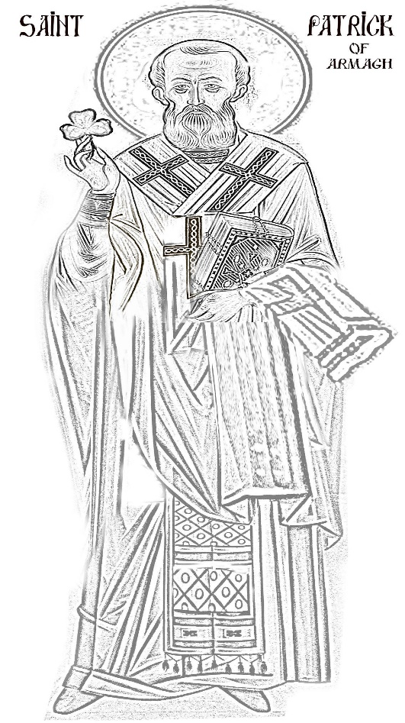

**ST JOSEPH & ST PATRICK**

**March 19, 2023**

**SUNDAYS Matins 9:45 10:30 am High Mass**

**Weekday Mass Tuesday (en français), Thursday 5:45 pm, Saturday 12 Noon**

**Tuesdays in Lent 7:30 pm ZOOM Compline & Conversation**

Order of service for High Mass (page 3)

Upcoming Services (page 2) Prayer List (page 11)

About St. John’s (back cover)



**SERVICES AT THE REDROOF**

***Spe salvi facti sumus*—in hope we were saved**

**Immediate Survival - Modest Maintenance-FRESH VISION- SUSTAINABLE NEW NORMAL**

**SUNDAYS 9:45 Matins 10:30 am**  **High Mass In church**

**TUESDAYS during LENT 7:30 p.m. Compline & Conversation ZOOM**

**Friday 7:00 p.m. sept à huit Bible Study ZOOM**

Permanent Zoom link:[**https://zoom.us/j/332912007**](https://zoom.us/j/332912007)

(or by phone **438-809-7799** Meeting ID: 332 912 007)

**WEEKDAY MASSES. TUESDAY 5:45 pm (en français) THURSDAY 5:45 pm**

**SATURDAY 12 NOON In Church**

***Monday to Friday Holy Eucharist at Christ Church Cathedral 12:15***

***During Term McGill's Birks Chapel***

***Tuesdays at 11:30 am for Holy Communion according to the 1962 BCP***

**LITURGICAL ALERTS**

**Wednesdays in Lent Stations of the Cross & Mass 5:45 pm**

**Saturday March 25, Annunciation Noon Mass**

For those visiting for the first time, welcome to St. John the Evangelist! And for our parishioners returning to worship in the church, welcome back!

* **Masks are no longer required by the government but are still encouraged as much as possible to protect the most vulnerable among us.**
* **Please clean your hands with sanitizer on the way in.**
* **Communion will be distributed at the altar rail in Both kinds** BUT if you do not wish to receive the chalice, please simply cross your arms. Intinction, the **dipping of the host into the cup IS NOT ALLOWED** to prevent contamination. If you are unable to come to the altar to receive communion please let the greeter at the table at the back of the church know and communion will be brought to you.
* The **bathroom** is located in the hallway to the left, through the door at the back of the church.

**AN ORDER OF SERVICE - HIGH MASS**

**Sunday, March 19, 2023- 10:30 am**

**Organ Prelude.** Prelude in C major, BuxWV 137, by D. Buxtehude (1637-1707)

**The Introductory Rite Mass setting:** Missa XVII

*The people stand at the sound of the bell.*

**THE ASPERGES**

Thou shalt purge me *O Lord, with hyssop, and I shall be clean: thou shalt wash me, and I shall be whiter than snow. *Psalm.* Have mercy upon me, O God, after thy great goodness. Glory be…Amen. Thou shalt purge me…

*Priest*: O Lord, show thy mercy upon us

*People:* **And grant us thy salvation.**

*Priest:*  O Lord, hear my prayer.

*People:* **And let my cry come unto thee.**

*Priest:* The Lord be with you

*People:* **And with thy spirit.**

Let us pray.

Graciously hear us, O Lord holy, Father, almighty, everlasting God and vouchsafe to send thy holy angel from heaven to guard and to cherish, to protect and visit, and to defend all who dwell in this thy holy habitation. Through Christ our Lord. Amen.

**Opening Hymn. # 472** *Pray that Jerusalem - YORK*

**THE LITURGY OF THE WORD**

**The Introductory Rite**

**Introit.**

*Rejoice ye with Jerusalem: and be ye glad for her, all ye that delight in her:* ***exult and sing for joy with her, all ye that in sadness mourn for her; that ye may suck, and be satisfied with the breasts of her******consolations****.* Psalm. *I was glad when they said unto me:* ***We will go into the house of the Lord.*** Glory be. Repeat antiphon.

*Priest.* Let us pray. *The people kneel.*

*Priest.* Our Father who art in heaven hallowed by thy name; thy kingdom come; thy will be done, on earth as it is in heaven. Give us this day our daily bread; and forgive us our trespasses, as we forgive them that trespass against us; and lead us not into temptation, but deliver us from evil. **Amen.**

*Priest.* Almighty God, unto whom all hearts be open, all desires known, and from whom no secrets are hid: Cleanse the thoughts of our hearts by the inspiration of thy Holy Spirit, that we may perfectly love thee, and worthily magnify thy holy Name; through Christ our Lord. **Amen.**

*Deacon.* Our Lord Jesus Christ said: Hear O Israel, The Lord our God is one Lord; and thou shalt love the Lord thy God with all thy heart, and with all thy soul, and with all thy mind, and with all thy strength. This is the first and great commandment. And the second is like unto it: Thou shalt love thy neighbour as thyself. On these two commandments hang all the Law and the Prophets.

*People.* **Lord, have mercy upon us, and write both these thy laws in our hearts, we beseech thee.**

**Kyrie eleison.**

**Kyrie eleison. Christe eleison. Kyrie eleison.**

**The Collect of the Day**

*Priest.* The Lord be with you.

*People.* **And with thy spirit.**

*Priest.* Let us pray.

GRANT, we beseech thee, Almighty God, that we, who for our evil deeds do worthily deserve to be punished, by the comfort of thy grace may mercifully be relieved; through our Lord and Saviour Jesus Christ. Amen.

O GOD Most High, who from the family of thy servant David didst raise up Joseph the carpenter to be protector of the Blessed Virgin Mary, the Mother of our Lord: Grant that we may so labour in our earthly vocations, that they may become labours of love and service offered unto thee, our Father; through the same our Lord Jesus Christ, who with thee and the Holy Spirit liveth and reigneth, one God, for ever and ever. Amen.

ALMIGHTY and everlasting God, who hatest nothing that thou hast made, and dost forgive the sins of all them that are penitent: Create and make in us new and contrite hearts, that we worthily lamenting our sins, and acknowledging our wretchedness, may obtain of thee, the God of all mercy, perfect remission and forgiveness; through Jesus Christ our Lord. Amen

**The First Lesson *Exodus 16: 2-7***

And the whole congregation of the children of Israel murmured against Moses and Aaron in the wilderness: and the children of Israel said unto them, Would to God we had died by the hand of the Lord in the land of Egypt, when we sat by the flesh pots, and when we did eat bread to the full; for ye have brought us forth into this wilderness, to kill this whole assembly with hunger. Then said the Lord unto Moses, Behold I will rain bread from heaven for you; and the people shall go out and gather a certain rate every day, that I may prove them, whether they will walk in my law, or no. And it shall come to pass, that on the sixth day they shall prepare that which they bring in; and it shall be twice as much as they gather daily. And Moses and Aaron said unto all the children of Israel, At even, then ye shall know that the Lord hath brought you out from the land of Egypt: and in the morning, then ye shall see the glory of the Lord.

**Gradual.**

*I was glad when they said unto me:* ***we will go into the house of the Lord.*** *Peace be within thy walls:* ***and plenteousness within thy palaces.***

**The Second** **Lesson *Galatians 4: 26-5:1***

Jerusalem which is above is free; which is the mother of us all. For it is written, Rejoice, thou barren that bearest not; Break forth and cry, thou that travailest not; For the desolate hath many more children that she which hath an husband. Now we, brethren, as Isaac was, are the children of promise. But as then he that was born after the flesh persecuted him that was born after the Spirit; even so it is now. Nevertheless, what saith the Scripture? Cast out the bond-woman and her son; for the son of the bond-woman shall not be heir with the son of the free-woman. So then, brethren, we are not the children of the bond-woman, but of the free. Stand fast therefore in the liberty wherewith Christ hath made us free.

**Tract**

*They that put their trust in the Lord, shall be even as the mount Syon:* ***which may not be removed, but standeth fast forever****. The hills stand about Jerusalem:* ***even so standeth the Lord round about***

***his people; from this time forth forevermore.***

**The Gospel** *St. John 6:5-14*

*Deacon.* The Lord be with you.

*People.* **And with thy spirit.**

*Deacon****.***The Holy Gospel is written in the sixth chapter of the Gospel according to Saint John, beginning at the fifth verse.

*People.* **Glory be to thee, O Lord.**

When Jesus then lift up his eyes, and saw a great company come unto him, he saith unto Philip, Whence shall we buy bread that these may eat? (And this he said to prove him; for he himself knew what he would do.) Philip answered him, Two hundred penny-worth of bread is not sufficient for them, that every one of them may take a little. One of his disciples, Andrew, Simon Peter’s brother, saith unto him, There is a lad here, which hath five barley-loaves, and two small fishes; but what are they among so many? And Jesus said, Make the men sit down. Now there was much grass in the place. So the men sat down, in number about five thousand. And Jesus took the loaves, and when he had given thanks, he distributed to the disciples, and the disciples to them that were set down; and likewise of the fishes, as much as they would. When they were filled, he said unto his disciples, Gather up the fragments that remain, that nothing be lost. Therefore they gathered them together, and filled twelve baskets with the fragments of the five barley-loaves, which remained over and above unto them that had eaten. Then those men, when they had seen the sign that Jesus did, said, This is of a truth that Prophet that should come into the world.

*People.* **Praise be to thee, O Christ.**

***Lent Prose #736***

**The Nicene Creed**

*Priest and people together.*

**I BELIEVE in one God the Father Almighty, Maker of heaven and earth, And of all things visible and invisible:**

**And in one Lord Jesus Christ, the only-begotten Son of God, Begotten of the Father before all worlds; God, of God; Light, of Light; Very God, of very God; Begotten, not made; Being of one substance with the Father; Through whom all things were made: Who for us men and for our salvation came down from heaven, And was incarnate by the Holy Ghost of the Virgin Mary, And was made man, And was crucified also for us under Pontius Pilate. He suffered and was buried, And the third day he rose again according to the Scriptures, And ascended into heaven, And sitteth on the right hand of the Father. And he shall come again with glory to judge both the quick and the dead: Whose kingdom shall have no end.**

**And I believe in the Holy Ghost, The Lord, The Giver of Life, Who proceedeth from the Father and the Son, Who with the Father and the Son together is worshipped and glorified, Who spake by the Prophets. And I believe One, Holy, Catholic, and Apostolic Church. I acknowledge one Baptism for the remission of sins. And I look for the Resurrection of the dead, And the Life of the world to come. Amen.**

**The Sermon** *Mtr Wendy Telfer*

**The Liturgy of the Eucharist**

**The Offertory**

**Offertory Verse.**

*O praise the Lord, for the Lord is gracious; O sing praises unto his Name, for it is lovely****: whatsoever the Lord pleased, that did he in heaven and in earth.***

***Offertory Hymn.* #476** *Rejoice the Lord is King – DARWALL*

**Offertory.** *Domine Deus salutis meae*byO. de Lassus (1532-1594)

*Priest.* Pray that my sacrifice and yours may be acceptable to God, the almighty Father.

*People.* **May the Lord receive this sacrifice at thy hands, to the praise and glory of his Name, to our benefit, and to that of all his holy Church.**

**The Intercessions**

*Deacon.* Let us pray.

*The deacon offers the biddings. After praying for the departed, the deacon says:*

Rest eternal grant unto them, O Lord, and let light perpetual shine upon them. **Amen.** Gathering together all our intercessions we entrust them to the prayer of Our Lady, Hail Mary, full of grace, the Lord is with thee. Blessed art thou among women, and blessed is the fruit of thy womb, Jesus.

*People.***Holy Mary, Mother of God, pray for us sinners now and at the hour of our death. Amen**

*The people kneel.*

*Priest.* Almighty and everliving God, who by thy holy Apostle hast taught us to make prayers and supplications, and to give thanks for all men: we humbly beseech thee most mercifully to accept our alms and oblations, and to receive these our prayers, which we offer unto thy divine Majesty; beseeching thee to inspire continually the universal Church with the spirit of truth, unity, and concord: And grant that all they that do confess thy holy Name may agree in the truth of thy holy word, and live in unity and godly love.

We beseech thee also to lead all nations in the way of righteousness; and to guide and direct their governors and rulers, that thy people may enjoy the blessings of freedom and peace: And grant unto thy servant *CHARLES* our King and to all that are put in authority under him, that they may truly and impartially administer justice, to the maintenance of thy true religion and virtue.

Give grace, O heavenly Father, to all Bishops, Priests, and Deacons, and specially to thy servant *MARY* our bishop, *LINDA* our primate, and *JUSTIN*, Archbishop of Canterbury, that they may both by their life and doctrine set forth thy true and living Word, and rightly and duly administer thy holy sacraments.

Prosper, we pray thee, all those who proclaim the gospel of thy kingdom among the nations: And to all thy people give thy heavenly grace, and specially to this congregation here present, that, with meek heart and due reverence, they may hear and receive thy holy Word; truly serving thee in holiness and righteousness all the days of their life.

And we most humbly beseech thee of thy goodness, O Lord, to comfort and succour all them who in this transitory life are in trouble, sorrow, need, sickness, or any other adversity, especially those for whom our prayers are desired.

We remember before thee, O Lord, all thy servants departed this life in thy faith and fear: and we bless thy holy Name for all who in life and death have glorified thee; especially the ever-Blessed Virgin Mary, Blessed John the Evangelist our Patron, St Joseph; St Patrick and all thy saints, beseeching thee to give us grace that, rejoicing in their fellowship, we may follow their good examples, and with them be partakers of thy heavenly kingdom.

Grant this, O Father, for Jesus Christ’s sake, our only Mediator and Advocate, to whom, with thee and the Holy Ghost, be all honour and glory, world without end. **Amen.**

**The Confession and Absolution**

*Deacon.* Ye that do truly and earnestly repent you of your sins, and are in love and charity with your neighbours, and intend to lead the new life, following the commandments of God, and walking from henceforth in his holy ways: Draw near with faith, and take this holy Sacrament to your comfort; and make your humble confession to Almighty God, meekly kneeling upon your knees.

*Priest and people together.* **ALMIGHTY GOD, Father of our Lord Jesus Christ, maker of all things, judge of all men: we acknowledge and confess our manifold sins and wickedness, which we from time to time most grievously have committed, by thought, word, and deed, against thy Divine Majesty. We do earnestly repent, and are heartily sorry for these our misdoings. Have mercy upon us, most merciful Father; for thy Son our Lord Jesus Christ’s sake, forgive us all that is past; and grant that we may ever hereafter serve and please thee in newness of life, to the honour and glory of thy Name; Through Jesus Christ our Lord. Amen.**

*Priest.* Almighty God, our heavenly Father, who of his great mercy hath promised forgiveness of sins to all them that with hearty repentance and true faith turn unto him: Have mercy upon you; pardon and deliver you from all your sins; confirm and strengthen you in all goodness; and bring you to everlasting life; through Jesus Christ our Lord. **Amen.**

*Deacon.* Hear what comfortable words our Saviour Christ saith unto all that truly turn to him.

Come unto me all that labour and are heavy laden, and I will refresh you. *Matthew 11:28*

God so loved the world, that he gave his only-begotten Son, to the end that allthat believe in him should not perish,but have eternal life. *John 3:16*

*Deacon.* Hear also what Saint Paul saith.This is a true saying, and worthy of all men to be received, that Christ Jesuscame into the world to save sinners. *1 Timothy 1:15*

*Deacon.* Hear also what Saint John saith. *I*f any man sin, we have an Advocate with the Father, Jesus Christ the righteous;and he is the propitiation for our sins. *1 John 2:1-2*

**The Eucharistic Prayer**

*Priest.* The Lord be with you;

*People.***And with thy spirit.**

*Priest.* Lift up your hearts;

*People.* **We lift them up unto the Lord.**

*Priest.* Let us give thanks unto our Lord God;

*People.***It is meet and right so to do.**

*Priest.* It is very meet, right, and our bounden duty, that we should at all times, and in all places give thanks unto thee, O Lord, Holy Father, Almighty, Everlasting God, Creator and Preserver of all things.

WHO by bodily fasting dost curb our sinfulness, uplift our hearts, and bestow both virtue and its reward upon us through Jesus Christ our Lord.

THEREFORE with Angels and Archangels and all the company of heaven, we laud and magnify thy glorious Name; evermore praising thee, and saying:

**Sanctus and Benedictus.**

**HOLY, HOLY HOLY, Lord God of Hosts. Heaven and earth are full of thy glory. Glory be to thee O Lord most high. Blessed is he that cometh in the name of the Lord: Hosanna in the highest.**

**The Consecration**

*Priest.*  BLESSING and glory and thanksgiving be unto thee Almighty God, our heavenly Father, who of thy tender mercy didst give thine only Son Jesus Christ to take our nature upon him, and to suffer death upon the Cross for our redemption; who made there, by his one oblation of himself once offered, a full, perfect, and sufficient sacrifice, oblation, and satisfaction, for the sins of the whole world; and did institute, and in his holy Gospel command us to continue, a perpetual memorial of that his precious death, until his coming again.

Hear us, O merciful Father, we most humbly beseech thee; and grant that we receiving these thy creatures of bread and wine, according to thy Son our Saviour Jesus Christ’s holy institution, in remembrance of his death and passion, may be partakers of his most blessed Body and Blood; who, in the same night that he was betrayed, took Bread; and, when he had given thanks, he brake it; and gave it to his disciples, saying, Take, eat; this is my Body which is given for you: Do this in remembrance of me. Likewise after supper he took the Cup; and, when he had given thanks, he gave it to them, saying, Drink ye all, of this; for this is my Blood of the new Covenant, which is shed for you and for many for the remission of sins: Do this, as oft as ye shall drink it, in remembrance of me.

     Wherefore, O Father, Lord of heaven and earth, we thy humble servants, with all thy holy Church, remembering the precious death of thy beloved Son, his mighty resurrection, and glorious ascension, and looking for his coming again in glory, do make before thee, in this sacrament of the holy Bread of eternal life and the Cup of everlasting salvation, the memorial which he hath commanded; And we entirely desire thy fatherly goodness mercifully to accept this our sacrifice of praise and thanksgiving, most humbly beseeching thee to grant, that by the merits and death of thy Son Jesus Christ, and through faith in his blood, we and all thy whole Church may obtain remission of our sins, and all other benefits of his passion; And we pray that by the power of thy Holy Spirit, all we who are partakers of this holy Communion may be fulfilled with thy grace and heavenly benediction; through Jesus Christ our Lord, by whom and with whom, in the unity of the Holy Spirit, all honour and glory be unto thee, O Father Almighty, world without end.

*Priest.* And now, as our saviour Christ has taught us, we are bold to say.

*Priest and people together.* **OUR FATHER who art in heaven, hallowed be thy Name, thy kingdom come, thy will be done, on earth as it is in heaven. Give us this day our daily bread; and forgive us our trespasses, as we forgive them that trespass against us; and lead us not into temptation, but deliver us from evil. For thine is the kingdom, the power, and the glory, For ever and ever. Amen.**

*Priest.* The peace of the Lord be always with you;

*People.* **And with thy spirit.**

*Priest and people together.* **WE DO NOT PRESUME to come to this thy Table, O merciful Lord, Trusting in our own righteousness, But in thy manifold and great mercies. We are not worthy So much as to gather up the crumbs under thy Table. But thou art the same Lord, Whose property is always to have mercy: Grant us therefore, gracious Lord, So to eat the Flesh of thy dear Son Jesus Christ, And to drink his Blood, That our sinful bodies may be made clean by his Body, And our souls washed through his most precious Blood, And that we may evermore dwell in him, And he in us. Amen.**

**The Communion**

**Agnus Dei.**

O Lamb of God, that takest away the sin of the world, have mercy upon us. O Lamb of God, that takest away the sin of the world, have mercy upon us. O Lamb of God, that takest away the sin of the world, grant us thy peace.

*Priest*. Behold the Lamb of God, which taketh away the sin of the world.

**Communion Sentence.**

*Jerusalem is built as a city that is at unity in itself****: for thither the tribes go up, even the tribes of the Lord, to give thanks unto the Name of the Lord.***

**Communion**.  "Adagio" in C major, BWV 564, by J. S. Bach (1685-1750)

**Communion Hymn. # 412** *Jerusalem the Golden - EWING*

**The Concluding Rite**

*Priest.*Almighty and everliving God, we most heartily thank thee that thou dost graciously feed us, in these holy mysteries, with the spiritual food of the most precious Body and Blood of thy Son our Saviour Jesus Christ; assuring us thereby of thy favour and goodness towards us; and that we are living members of his mystical body, which is the blessed company of all faithful people; and are also heirs through hope of thy everlasting kingdom.

*Priest and people together.* **AND HERE** **we offer and present unto thee, O Lord, ourselves, our souls and bodies, to be a reasonable, holy, and living sacrifice unto thee. And although we are unworthy, yet we beseech thee to accept this our bounden duty and service, not weighing our merits, but pardoning our offences; through Jesus Christ our Lord, to whom, with thee and the Holy Ghost, be all honour and glory, world without end. Amen.**

*Priest****.*** Grant we beseech thee, merciful God that we may celebrate with sincere worship the mysteries which are our daily food, and ever receive them with faithful hearts. Through Jesus Christ our Lord. Amen*.*

The Peace of God, which passeth all understanding, keep your hearts and minds in the knowledge and love of God, and of his Son Jesus Christ our Lord: and the blessing of God Almighty, the Father, the Son, and the Holy Ghost, be amongst you and remain with you always. **Amen.**

*Deacon.*Let us Bless the Lord.

*People.* **Thanks be to God.**

**Hymn.** # 68 *The Glory of these forty days - ERHALT' UNS, HERR*

**Postlude.** Fugue in F major, BWV 540, by J.  S. Bach

**Fourth Sunday in Lent**

**Refreshment Sunday** *Peter Harper*

Called Laetare Sunday from its Officium (Introit), this day is also known as Refreshment Sunday, Mid-Lent Sunday, Mothering Sunday, Jerusalem Sunday, New Sunday, Rose Sunday, Alb Sunday, and Sunday of the Five Loaves.

On this Sunday, we temper the ascetism of Lent. On the previous Thursday, 20 of the 40 days have passed. We pause a little before taking on the second half. The Service contains the ancient Gregorian Collect which speaks of the “comfort of thy grace” and the Gospel relates the feeding of the multitude. Popes traditionally distributed bread to the poor in re-enactment of this event.

The Epistle refers to “Jerusalem” which is the mother of us all”, and it was a custom in many cities to visit the main or mother church of the area; thus, the Romans assemble in the Basilica of the Holy Cross (S. Croce in Gerusalemme), their symbolic Jerusalem (this is perhaps also related to the fact that Eastern churches celebrate Holy Cross Day on this Sunday).

The reference to ‘mother’ led to the English custom of visiting one’s mother on this day. Special pastries called Simmel or Mothering cakes, and violets were brought as gifts. There was a similar pagan festival at this time on the Ides of March, that of Hilaria, the Mother of the Gods, which was associated with family reunions. There may be no connection between the two feasts. The Pope sometimes blesses a Golden Rose (an natural rose in earlier times, but since the 11thc. a gold ornament) on this day and anoints it with chrism and scents it with balsam and musk in remembrance of “the root of Jesse”. The rose is sent to a sovereign, a dignitary, a church, or a city, which is to be honoured. Henry VIII received one from three different popes. This is recalled in our use of rose coloured vestments on this Sunday.

Wednesday next in the Early Roman Church was the day of the Great Scrutiny when catechumens were given an important test as preparation for this baptism at the Easter Vigil.

They were sealed (signed with the cross) by their sponsors, submitted to exorcisms and read the prophets (Ex. 31: 23-8, Is. 1: 16-19). Salt was put on their tongues. Their ears were symbolically unstopped with the “*Ephpheta*”. They were then initiated to some of the “secrets” of the Church (*Traditio symbolorum*): the 4 Gospels (the opening verses of each were read), the Symbols (the Apostles’ Creed, and at a later date the Nicene Creed, read to them in Greek and Latin), and the Lord’s Prayer (explained to them). After the Gospel of the Healing of the Blind Man, they left the Church, but were especially remembered in the Intercession. Part of this ceremony has survived in our Baptismal Rite, particularly that for “Such as are of riper years”, in the Creed and the supplication before Baptism.

**Prayers of the People**

**In Faith, Hope and Charity let us pray for the good estate of the Catholic church.** *We give thanks for our collective health and resilience at this time. We continue to pray for all medical staff; hospitals and clinics.*  **We remember** *St. Michael and all Angels, Winnipeg; Our Diocesan prayer partners, The Territory of the People and the Diocese of Masasi; and the community of St. Michael’s Mission. For those who suffer injustice and those who work for justice and peace. We pray for the end of the conflict between Ukraine & Russia, for all the peoples of the world contending with extremism, violence and polarization. Let us pray for Canada’s Indigenous peoples; for our Earth and its living systems, and those suffering from natural and human caused disasters.* ***We also pray for our parish that we may continue as a community of faith.***

[***Anglican Cycle of Prayer (March 19-25)***](https://anglicancommunion.org/media/422641/acp_from-aba-to-zululand-2021-to-2023_web.pdf)

**Sun** The Anglican Church of Southern Africa

**Mon** The Diocese of Rokon – The Province of the Episcopal Church of South Sudan

**Tues** The Diocese of Rorya – The Anglican Church of Tanzania

**Wed** The Diocese of Ruaha – The Anglican Church of Tanzania

**Thu** The Diocese of Ziwa (Lake) Rukwa – The Anglican Church of Tanzania

**Fri** The Diocese of Rumbek – The Province of the Episcopal Church of South Sudan

**Sat** The Diocese of Rumonge – The Anglican Church of Burundi

[***Diocesan Cycle of Prayer***](https://static1.squarespace.com/static/53339102e4b00c509597c34c/t/6001f5b4514b6c73056efd5b/1610741172969/Prayer+Roster+2021.pdf)

**Sun** St George’s, Châteauguay The Ven Robert Camara, Interim Clergy

**Mon** Trinity Church, St-Bruno The Rev Roslyn Macgregor

**Tues** St Barnabas, St-Lambert The Rev Brian Perron

**Wed** Christ Church, Sorel The Rev Denis Gévry

**Thu** Hemmingford / Havelock St Luke, Hemmingford The Rev Nick Brotherwood Trinity, Havelock

**Fri** St George, Granby St Paul, Abbotsford The Rev Fresia Saborio

**Sat** Church of the Epiphany The Rev Amy Hamilton The Rev Deacon Jean Willcocks, Deacon

**For those in special need:** Marc & Josephine,Jim Best, Mildred Fletcher, Hallam Taylor

**For continuing support:**Simon, Karen, Charles, Fr Richard Cawley, Jayne Demakos, Garrfield Du Couturier-Nichol, Diane, Réal Guérin, Tony Whitehead, Juanita Docherty-McFarlane, Ian MacLean, Vessella, Glenn Cartwright, Geraldine Doran, Desmond Murphy, Mike Curry, Tom Byford, Deirdre Hitchcox, Frances Kemp, Thomas Numann, Sandra Guillaume, Peter Iveson, RoseMary, Louise Driver, BB Gaylord, Hannah Brockow, Alexandra Belden, Anny Guillemette, Tanya

***Commemorations (March 19-25)***

**Sun** Philip Johnson, Anna Hague, Henry Skelton, Efra Prudence Heward, William Chouinard

**Mon**  Charles Fides, Elizabeth Jones, William Ferguson, Mary Evans

**Tues** Meredith Haskill, Bernard Wilkenson, Ruth Pierson

**Wed** Henry Wisemen, Annie Porter, Rdna Webb, James Rosevear, Jessie Lord, Aline Sklivas, Dorthey

Stewart

**Thur** Edmund Newton, Edward Marchment

**Fri** Edward Waud, Emmanuel Greenbaum Priest, Mabel Brighton, Anne Smith

**Sat** Sarah Hardie, Evelyn Brown, Steward Draper, James Waud

*Please contact* [*Mother Wendy*](mailto:thurifer@hotmail.com) *or* [*Father Keith*](mailto:rector@redroof.ca) *with additions or changes to the prayer list*

**THE CHURCH OF** **ST. JOHN THE EVANGELIST**

**At the cutting edge of Tradition & a resource for the wider Church**

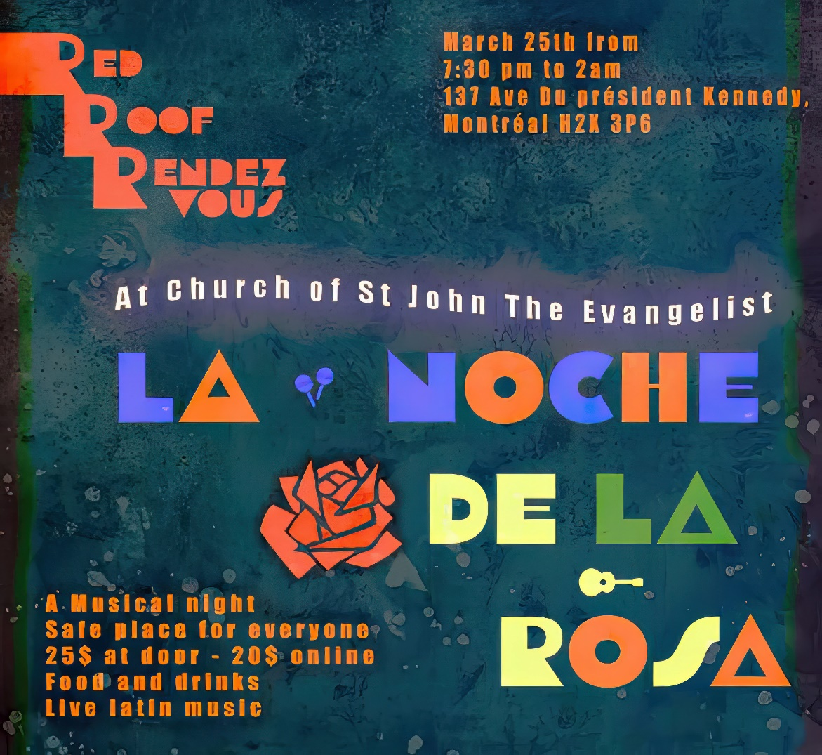

**PROMENADE DES ARTISTES**

137 President Kennedy Avenue

Montreal (Quebec) H2X 3P6

redroof.mtl**

 **office@redroof.ca     514-288-4428**[**www.redroof.ca**](http://www.redroof.ca/)

**THE REV’D CANON KEITH A. SCHMIDT, RECTOR**

[**rector@redroof.ca**](mailto:rector@redroof.ca)514-717-4930 (Cell)  514-288-6130 (Study)

**Associate Priests:**The Rev’d Wendy H. Telfer - [thurifer@hotmail.com](mailto:thurifer@hotmail.com) - 514-506-2386

The Rev’d Marc-Philippe Vincent – [marc-philippe.vincent@redroof.ca](mailto:marc-philippe.vincent@redroof.ca) - 514-915-2067

**Assistant Curate:** The Rev’d Susan Searle - [inguz@sympatico.ca –](mailto:inguz@sympatico.ca%20-) 438-823-2106.

**Honorary Assistant:** The Rev’d Dr. Richard  Cawley, **Honorary Associate**: Captain the Rev’d Alain Brosseau

**Assistant Priest Emeritus**: The Rev’d Canon Dr. J. Simons

**Director of Music:**Dr Federico Andreoni

**Wardens:** Geoffrey Little and Sara Bohl Pistolesi