

**Church of St. John the Evangelist**

**THE EASTER VIGIL**

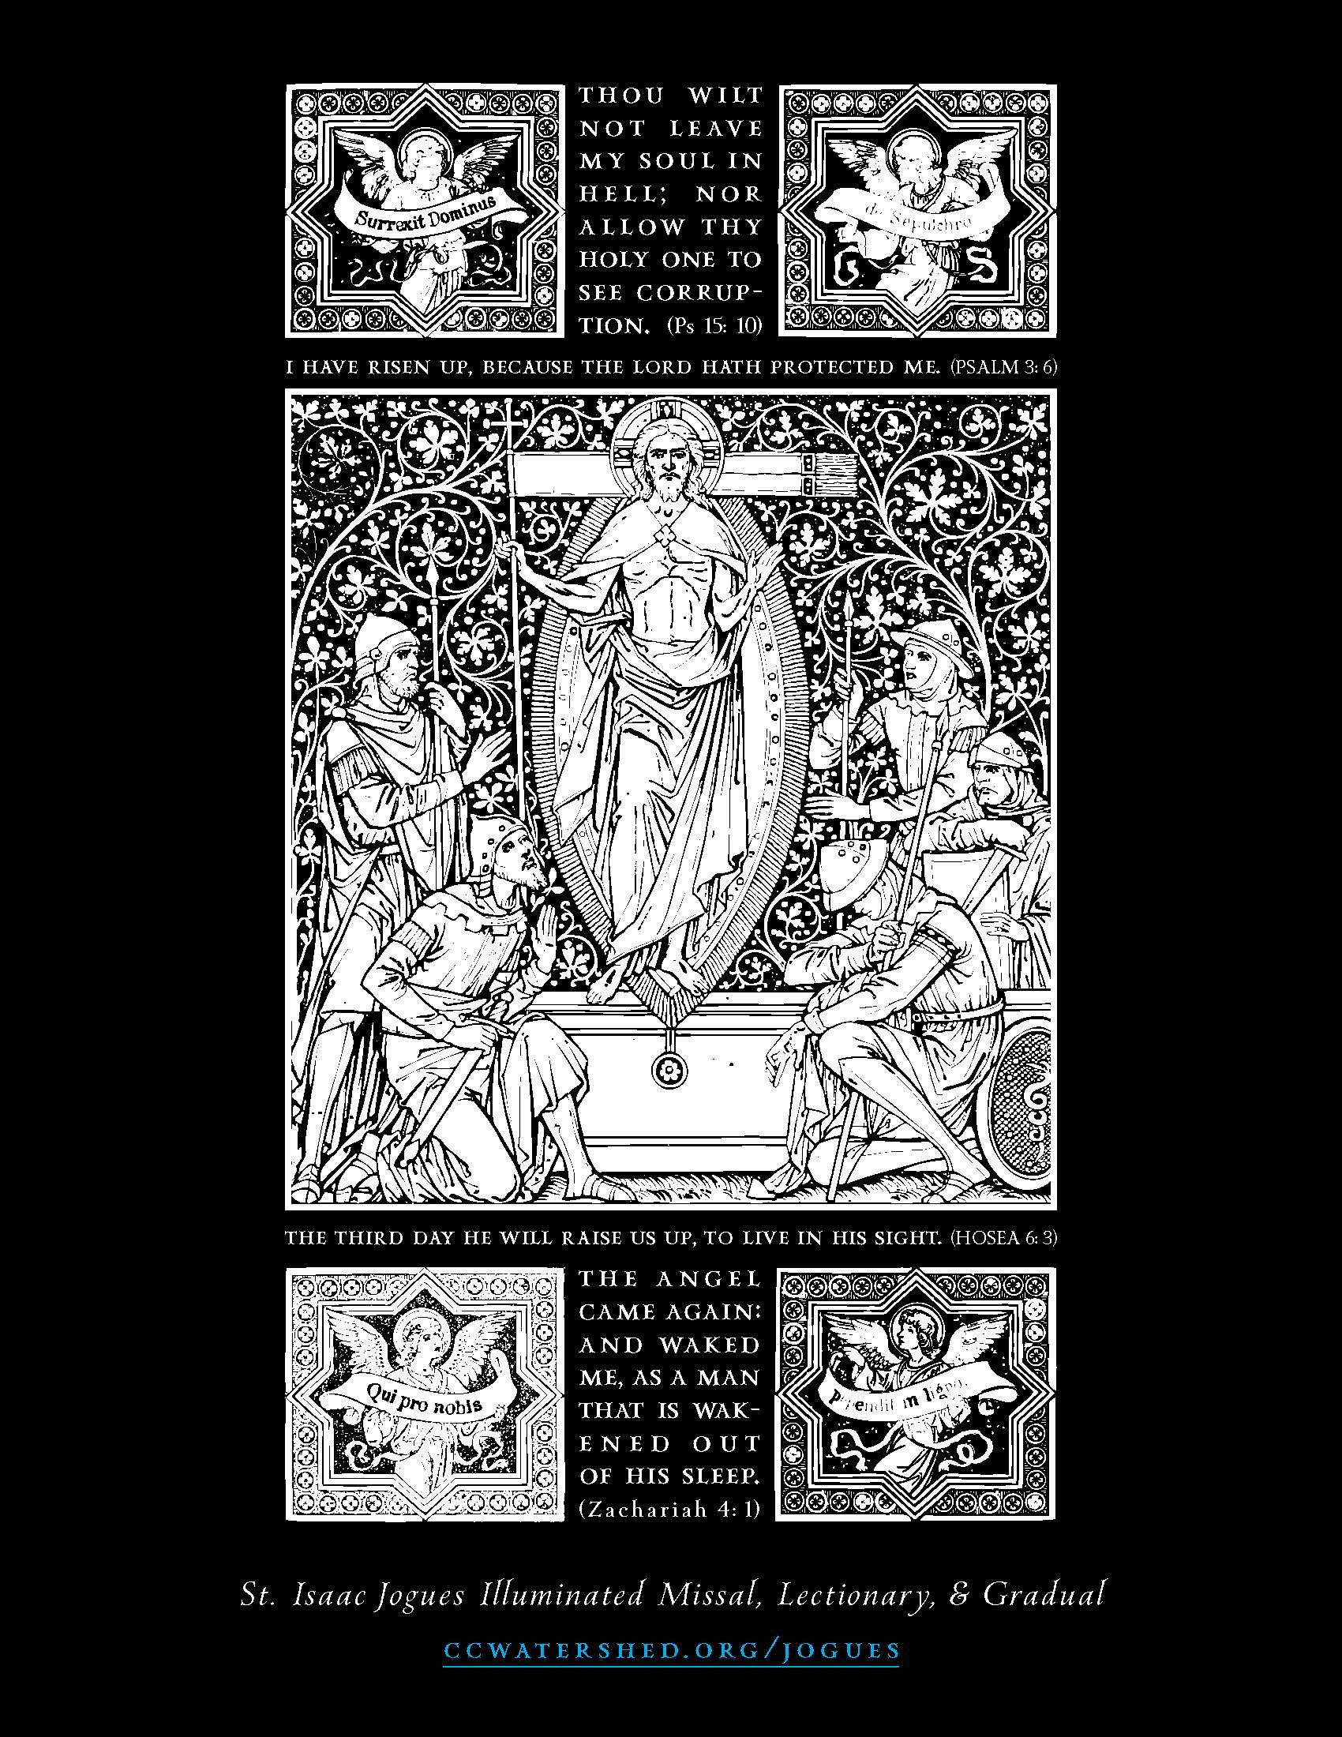

**April 9, 2023**

**SUNDAYS Matins 9:45 10:30 am High Mass**

**Weekday Mass Tuesday (en français), Thursday 5:45 pm, Saturday 12 Noon**

**Tuesdays in Lent 7:30 pm ZOOM Compline & Conversation**

Order of service for High Mass (page 3)

Upcoming Services (page 2) Prayer List (page 11)

About St. John’s (back cover)



**SERVICES AT THE REDROOF**

***Spe salvi facti sumus*—in hope we were saved**

**Immediate Survival - Modest Maintenance-FRESH VISION- SUSTAINABLE NEW NORMAL**

**SUNDAYS 9:45 Matins 10:30 am High Mass**

**Wednesdays 7:30 p.m. Compline & Conversation ZOOM**

**Friday 7:00 p.m. sept à huit Bible Study ZOOM**

Permanent Zoom link:[**https://zoom.us/j/332912007**](https://zoom.us/j/332912007)

(or by phone **438-809-7799** Meeting ID: 332 912 007)

**WEEKDAY MASSES. TUESDAY 5:45 pm (en français) THURSDAY 5:45 pm**

**SATURDAY 12 NOON In Church**

***Monday to Friday Holy Eucharist at Christ Church Cathedral 12:15***

**LITURGICAL ALERTS**

**Monday in Easter Week Mass 5:45 pm**

**April 16 Octave Day of Easter**

**Visit of the Order of St Lazarus, please come and**

**welcome our guests at High Mass**

**SPECIAL VESTRY APRIL 23 AFTER HIGH MASS in Person**

For those visiting for the first time, welcome to St. John the Evangelist!

**Masks are no longer required by the government but are still encouraged as much as possible to protect the most vulnerable among us.**

* **Communion will be distributed at the altar rail in Both kinds** BUT if you do not wish to receive the chalice, please simply cross your arms. Intinction, the **dipping of the host into the cup IS NOT ALLOWED** to prevent contamination. If you are unable to come to the altar to receive communion please let the greeter at the table at the back of the church know and communion will be brought to you.
* The **bathroom** is located in the hallway to the left, through the door at the back of the church.

**HOLY SATURDAY, THE EASTER VIGIL**

April 8 8:00 pm



**The Lighting of the New Fire and Blessing of the Paschal Candle**

*At the south door. In the darkness, a fire is kindled. The priest then blesses the new fire, saying,*

*Priest:* The Lord be with you.

*People:* **And with thy spirit.**

Let us pray. O God, who through thy Son, who is the true cornerstone, hast bestowed upon thy faithful people the fire of thy brightness: we beseech thee that thou wouldest sanctify this new fire, now struck by us from the flintstone, to be profitable to our service: and grant unto us that by this Paschal Feast we may be so inflamed with heavenly desires, that we may with pure hearts and minds attain unto the feast of thy eternal brightness. Through the same Jesus Christ our Lord. Amen.

***The Paschal Candle is marked with a Cross, the Alpha and Omega, and the year saying***

Christ yesterday and today, the Beginning and the End, Alpha and Omega; all time

belongs to him and all the ages; to him be glory and power through every age for ever. **Amen.**

***He inserts five grains of incense into the candle in the form of a cross, saying,***

By his holy and glorious wounds may Christ our Lord guard us and keep us*.* **Amen.**

***He then lights the candle from the new fire, saying,***

May the LIGHT OF CHRIST, gloriously rising, scatter the darkness of heart and mind*.*

***He gives the Candle to the Deacon and Blesses, it saying,***

Pour thine abundant blessing upon this lighted candle, we beseech thee, almighty God; look down upon it, invisible creator of new life, as it shines in the darkness; that not only the sacrifice that is offered this night may shine by the secret mixture of thy light; but also that in whatever place any part of this mystically blessed candle shall be brought, the power of thy majesty be present and the malice of satanic deceit may be driven away. Through Christ our Lord. **Amen**

*Deacon:* The Light of Christ.

*People****:* Thanks be to God.**

**After the third proclamation, the tapers of the people are lighted, and the candle is placed on a temporary stand in the chancel, next to the place from which the Deacon sings The Exsultet.**

Now let the Angelic host of heaven rejoice: let the divine mysteries rejoice: and for the victory of the mighty King let the trumpet of salvation sound forth. Let the earth also be glad, illumined by the rays of this great brightness, and enlightened by the splendour of the eternal King let her know that she hath put away the darkness of the whole world. Let our mother the Church also rejoice, adorned with the brightness of so great a light: and let this temple resound with the triumphant voices of the peoples. Wherefore, dearly beloved brethren, who are here present in the wondrous clearness of this holy light, join with me I beseech you, in calling upon the mercy of almighty God. That he who hath been pleased, for no merit of mine, to admit me into the number of his Levites: may pour upon me the brightness of his light, and make me meet to proclaim the praises of this candle. Through Jesus Christ his Son our Lord: Who liveth and reigneth with him in the unity of the Holy Ghost, God. Throughout all ages, world without end. Amen.

*Deacon:*The Lord be with you*.*

*People:* **And with thy spirit**.

*Deacon:*Lift up your hearts*.*

*People:* **We lift them up unto the Lord**

*Deacon:*Let us give thanks unto our Lord God*.*

*People:* **It is meet and right so to do.**

It is very meet and right that we should, with the whole affection of our heart and mind, and with the service of our lips, give praise unto the invisible God, the Father Almighty. And unto his only begotten Son, Jesus Christ our Lord. Who paid for us to the eternal Father the debt of Adam's transgression: and with his dear blood wiped away the reproach of our former offences. For this is the Paschal Feast wherein the very Lamb is slain, by whose blood the doorposts of the faithful are made holy.

This is the night, wherein of old thou didst lead forth our fathers, the children of Israel out of Egypt, and didst make them to pass as on dry land through the Red Sea. Yea, this is the night, that with the brightness of the pillar hath purged away the darkness of iniquity.

This is the night, which throughout the whole world today doth separate them that believe in Christ from the wickedness of the age, and from the darkness of transgressions, reneweth them unto grace, restoreth them to holiness.

This is the night wherein, breaking the chains of death, Christ ascended from hell in triumph. For nought indeed had it profited us to be born, if it had it not profited us to be redeemed. O how wonderful the condescension of thy loving kindness! O how inestimable the goodness of thy love: who to redeem a slave didst deliver up thy Son! O truly necessary sin of Adam, which by the death of Christ was done away! O happy fault, which was counted worthy to have such and so great a Redeemer! O night truly blessed, which alone was worthy to know the time and hour wherein Christ rose again from hell!

This is the night whereof it is written: And the night is as clear as the day: and, then shall my night be turned into day. The sanctifying power therefore of this night putteth to flight the deeds of wickedness, washeth away sins: restoreth innocence to the fallen, and joy to them that mourn: casteth out enmities, prepareth concord, and boweth down principalities.

Therefore in this night of grace accept, O holy Father, the evening sacrifice of this incense: which by the hands of thy ministers, Holy Church doth lay before thee, in the solemn offering of this candle, made from the work of bees. But we already know the excellency of this pillar, which for the honour of God the sparkling fire doth kindle. Which, though it be divided into parts, suffereth not loss by the borrowing of its light. For it is fed by melting wax, which the bee the mother hath wrought into the substance of this precious candle. O night truly blessed, which did spoil the Egyptians, and make rich the Hebrews! O night wherein heavenly things are joined unto earthly, things human unto things divine! We therefore pray thee, O Lord: that this candle, consecrated to the honour of thy name, may continue without ceasing to vanquish the darkness of this night. That, being accepted for a savour of sweetness, it may be mingled with the lights of heaven. May the morning star find it burning, that morning star, I say, which knoweth not his going down. That star, which rising again from hell, steadfastly giveth light to all mankind. We therefore pray thee, O Lord that thou wouldest vouchsafe to rule, govern and preserve with thy continual protection us thy servants, the whole clergy and thy most faithful people: together with our most blessed father *JUSTIN* and our Bishop, Mary, granting us peaceful times in this our pascal joy.Look also on those who rule in power, and by the ineffable gift of thy goodness and mercy direct their thoughts to justice and peace, that from the busy toil of earth they may attain unto the heavenly country with all thy people. Through the same Jesus Christ thy Son our Lord: Who liveth and reigneth with thee in the unity of the Holy Ghost, God throughout all ages, world without end. **Amen.**

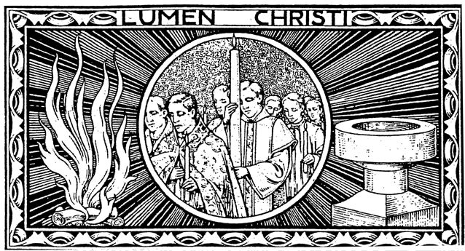

**THE PROPHECIES**

**THE FIRST PROPHECY: THE CREATION** *A Reading from the Story of Creation from the Book of Genesis*

**COLLECT**

O God, who in a wondrous manner didst create the race of man, and still more wondrously hast redeemed the same: grant us, we beseech thee, so steadfastly to withstand all the crafts and devices of sin, that we may be found worthy to attain everlasting felicity. Through Jesus Christ our Lord. **Amen.**

**THE SECOND PROPHECY: THE FLOOD** *A Reading from the Story of the Flood from Genesis*

**COLLECT**

O God of unchangeable power and eternal light: look favourably upon thy whole Church, that wonderful and sacred mystery; and by the tranquil operation of thy perpetual providence carry out the work of man’s salvation; that things which were cast down may be raised up, and that all things may return into unity through him by whom all things were made, even thy Son Jesus Christ our Lord. **Amen**

**THE THIRD PROPHECY: THE PASSAGE THROUGH THE RED SEA**  *A Reading from Exodus*

**CANTICLE**

*We will sing unto the Lord: for He has triumphed gloriously: the horse and his rider hath He thrown into the midst of the sea: the Lord is my strength and song, and He is become my salvation. He is my God, and I will praise Him: my Father's God and I will exalt Him. The Lord is a man of war: the Lord is his Name.*

**COLLECT**

O God, who hast ordained that thy mighty works of oldshould enlighten even this our present generation: who didst by the mighty defence of thy right hand deliver one people from persecution in the land of Egypt to be a figure of the salvation of all nations by the washing of regeneration: grant, we pray thee, that the fullness of all mankind, being delivered from its present bondage, may be made sons of Abraham and worthy members of thy true Israel. Through Jesus Christ our Lord. **Amen.**

**THE FOURTH PROPHECY: THE BRANCH OF THE LORD**

*A reading from Isaiah*

**CANTICLE**

*My well-beloved hath a vineyard in a very fruitful hill. And he fenced it, and gathered out the stones thereof: and planted it with the choicest vine: and built a tower in the midst of it. And also made a winepress therein: for the vineyard of the Lord of hosts is the house of Israel.*

**COLLECT**

O God, who by the mouth of thy holy prophets hast manifest Thyself before all the children of the Church, to be in all places of thy dominion, the sower of good seed and the husbandman of thine elect branches: grant unto thy peoples, that, the vineyard of thy planting and the harvest of thy sowing being purged of all thorns and briars, they may be made to bring forth worthy fruit in abundance, through Jesus Christ our Lord. **Amen.**

**THE BLESSING OF THE BAPTISMAL WATER**

*Priest:*The Lord be with you*.*

*People:* **And with thy spirit**.

*Priest:*Lift up your hearts*.*

*People:* **We lift them up unto the Lord**

*Priest:*Let us give thanks unto our Lord God*.*

*People:* **It is meet and right so to do.**

***A large vessel of water is set up before the congregation***

*Priest:* It is very meet, right, and our bounden duty, that we should give thanks unto thee, O Lord Holy Father almighty, everlasting God whose invisible power produces through his sacrament remarkable effects.  O God, whose Spirit moved over the face of the waters, when the earth was without form and void at its creation: behold with thy good pleasure the family of thy Church, and make the grace of thy regeneration abound therein, for thou dost with the rivers of thy plenteous mercy make glad the city of the redeemed: and open unto us the fountains of baptism through the whole world for the healing of nations that, at the word of thy majesty, the same may receive the grace of thine only Son, through the Holy Ghost.

***The Celebrant divides the water in the form of the cross***

May he by the secret operation of his power make this water fruitful unto the regeneration of man that having received sanctification, and being born again without spot of defilement, the same may be found a new creature, that springeth from this womb of living water:  that young and old, both men and women, who henceforth shall be baptized therein, may all become the children of grace and heir of thy heavenly promises.

***He touches the water***

Be this a holy and undefiled creature, and such that the son of wickedness may not approach it, nor the stain of iniquity come near to defile it.  Be it a fountain that doth regenerate, a stream that doth purify: may all they that by this means shall be dedicated before thee by the operation of the Holy Ghost, receive the grace of redemption and remission of their offences.

***He signs the water 3 times***

Wherefore, I do hallow, thee, a creature of water, by God that liveth, by God the faithful, by God the holy: by God, who in the beginning by his word divided the land from thee and whose Spirit moved upon thy face.

***He divides the water with his hand and scatters a little towards the 4 corners of the earth***

Who did ordain that thou shouldst issue out of Eden, and be parted from thence into four heads, flowing there from into all the earth.  Likewise in the desert of Marah, he didst turn the bitterness into sweetness and made thee to come forth out of the rock for his people.

In the name of his only Son our Saviour Jesus Christ do I hallow thee, O creature of water for he did change thee into wine as a wondrous sign of his omnipotence, when he was bidden to the wedding at Cana.  Who walked upon thee with his feet to come to his disciples and was baptized in thee in Jordan by John his minister.  Who moreover did mingle thee with blood from his side at his Passion:  and commanded his disciples that such as believe should be in thee baptized, saying:  Go teach all nations, and baptize them in the name of the Father, and of the Son, and of the Holy Ghost.

***Dipping the candle 3 times in the form of a cross***

Hallow by the word of thy mouth and of thy power the weakness of this water, that like as by nature it doeth service unto the purifying of the body, so by thy grace it may effectually cleanse our soul.

***Dipping the candle 3 times in the water, each time a little deeper***

 May the power of the Holy Ghost may be poured out on this font which we have filled.

***He blows on the water.***

And make the whole substance of this water effectual unto the washing of regeneration.

***The candle is removed***

May every stain of our iniquity here be cleansed; may our nature be restored to its perfect fashioning, and be conformed again to thine own image of righteousness; may it be redeemed from the old sins of its conversation:  Through Jesus Christ thy Son our Lord, who shall come to judge the quick and the dead, and the world by fire.  Amen.

***Oil is poured in the form of a cross upon a small portion of the water in a vase***

May this Oil of Salvation make this water holy and fruitful, in such wise that those who find therein that new birth may come to life everlasting.  Amen.

May this commingling of the Oil of salvation and of the water of baptism be wrought in the name of the Father, and of the Son, and of the Holy Ghost.  Amen.

***The vase of Baptismal Water is carried in procession to the baptistery***

**CANTICLE**

*Like as the hart desireth the water-brooks: so longeth my soul after thee, O God. My soul is athirst for God, even for the living God: when shall I come to appear before the presence of God? My tears have been my meat day and night, which they daily say unto me: Where is now thy God?*

**THE RENEWAL OF BAPTISMAL VOWS**

*Priest:* On this most holy night, dearly beloved, our holy Mother the Church, calling to mind the death and burial of our Lord Jesus Christ, rendereth unto Him love, and keepeth vigil and awaiting his glorious resurrection rejoiceth with great gladness. Wherefore dearly beloved, now that our Lenten exercises are over, let us renew the promises made in Holy Baptism, whereby we once renounced Satan and all his works and likewise the world which is the enemy of God, and promised to serve God faithfully in his Holy Catholic Church, I demand, therefore,

*Priest:* Do you here, in the presence of God, renounce the devil and all his works, the pomps andvanity of this wicked world, and all the sinful lusts of the flesh, so that you will not follownor be led by them?

*People:***I do.**

*Priest:* Let us recite the Articles of our belief.

**I believe in God the Father Almighty, Maker of heaven and earth:**

**And in Jesus Christ his only Son our Lord,**

**Who was conceived by the Holy Ghost, Born of the Virgin Mary,**

**Suffered under Pontius Pilate, Was crucified, dead, and buried:**

**He descended into hell; The third day he rose again from the dead;**

**He ascended into heaven, And sitteth on the right hand of God the Father Almighty;**

**From thence he shall come to judge the quick and the dead.**

**I believe in the Holy Ghost; The holy Catholic Church;**

**The Communion of Saints; The Forgiveness of sins,**

**The Resurrection of the body, And the Life everlasting. Amen.**

*Priest:* Do you profess this faith?

*People:* **I do.**

*Priest:* Will you endeavour to keep God’s holy will and commandments, and to walk in the same, all the days of your life?

*People:***I will, God being my helper.**

*Priest:* May almighty God, the Father of our Lord Jesus Christ, who hath regenerated us by Water and the Holy Spirit, and hath given unto us forgiveness of all our sins, himself Guard us by his grace and everlasting life, in the same Christ Jesus our Lord*.* **Amen**

***Easter eggs may be blessed at this time and the congregation is sprinkled with newly-blessed water as the ministers make their way through the church to the sacristy.***

**THE ASPERGES**

*Thou shalt purge me, O Lord, with hyssop, and I shall be clean:  Thou shalt wash me, and I shall be whiter than snow.*

Have mercy upon me, O God, after thy great goodness.  According to the multitude of thy mercies, do away mine offences.*Thou shalt purge me, O Lord, with hyssop, and I shall be clean:  Thou shalt wash me, and I shall be whiter than snow.*

Wash me thoroughly from my wickedness, and cleanse me from my sin. *Thou shalt purge me, O Lord, with hyssop, and I shall be clean:  Thou shalt wash me, and I shall be whiter than snow.*

Thou shalt make me hear of joy and gladness; that the bones which thou hast broken may rejoice. *Thou shalt purge me, O Lord, with hyssop, and I shall be clean:  Thou shalt wash me, and I shall be whiter than snow.*

**The litany of the saints**

O God the Father, Creator of heaven & earth, **Have mercy upon us.**

O God the Son, Redeemer of the World, **Have mercy upon us**

O God the Holy Ghost, **Have mercy upon us.**

Holy Trinity, one God, **Have mercy upon us**

Holy Mary, **Pray for us,** Holy Mother of God**, Pray for us** Holy Virgin of virgins,...Holy Michael,...

Holy Gabriel, Holy Raphael,...All ye holy Angels and Archangels,...All ye holy orders of Blessed Spirits,...

Holy John Baptist,...Holy Joseph,...All ye holy Patriarchs and Prophets, **Pray for us.**

Holy Peter, **Pray for us**. Holy Paul,...Holy Andrew, ...Holy John the Evangelist,...All ye holy Apostles and Evangelists,...All ye holy disciples of the Lord,...Holy Stephen,...Holy Lawrence,...Holy Vincent,... Holy Jean de Brébeuf & his Companions,...All ye holy Martyrs,... Holy Sylvester,...Holy Gregory,...Holy Augustine,... Holy François de Laval,... All holy Bishops and confessors,... All ye holy doctors,...Holy Anthony,...Holy Benedict,...Holy Dominic,...Holy Francis,...All ye holy Priests and Levites,... Holy Br. André,... All ye holy Monks and Hermits,...Holy Mary Magdalene, ...Holy Agnes,...Holy Cecilia,...Holy Agatha,...Holy Anastasia,... Holy Marguerite d’Youville,... Holy Marie de l’Incarnation,...Holy Marguerite Bourgeoys,...Holy Kateri Tekakwitha, **Pray for us**

All ye holy virgins and widows, **Pray for us**

All ye holy Men and Women, Saints of God, **Intercede for us.**

Be Thou merciful**, Spare us, O Lord**

Be Thou merciful, **Graciously hear us, O Lord**

We sinners, **Beseech thee, hear us**

That thou wouldst spare us, **We beseech thee, hear us.**

That it may please Thee to govern and preserve thy holy church...

That it may please Thee to strengthen and preserve us

in thy holy service...

That it may please Thee to give and preserve

the fruits of the earth...

That it may please Thee to grant to all the faithful departed

rest eternal...

That it may please Thee, graciously to hear us

**We beseech thee, hear us.**

O Lamb of God, that takest away the sin of the World, **Spare us, O Lord.**

O Lamb of God, that takest away the sin of the world,**Graciously hear us, O Lord.**

O Lamb of God, that takest away the sin of the World.

**Have mercy upon us.** O Christ hear us**O Christ, graciously hear us.**

**Towards the end of the Litany, the Ministers enter and make their way to the altar**

**THE FIRST SOLEMN MASS OF EASTER**

**Mass setting.** *Missa Brevis* by G. P. da Palestrina (1525-1594) 

*Kyrie eleison. Kyrie eleison. Kyrie eleison.*

*Christe eleison. Christe eleison. Christe eleison.*

*Kyrie eleison. Kyrie eleison. Kyrie eleison*

***The priest and sacred ministers go to the altar. the priest intones and sings***

Glory be to God on high,

**and in earth peace, good will towards men.**

**We praise thee, we bless thee, we worship thee, we glorify thee,**

**we give thanks to thee for thy great glory.**

**O Lord God, heavenly King; God the Father almighty.**

**O Lord, the only begotten Son, Jesu Christ:**

**O Lord God, Lamb of God, Son of the Father,**

**that takest away the sin of the world, have mercy upon us.**

**Thou that takest away the sin of the world, receive our prayer.**

**Thou that sittest at the right hand of God the Father, have mercy upon us.**

**For thou only art holy, thou only art the Lord;**

**thou only, O Christ, with the Holy Ghost,**

**art most high in the glory of God the Father. Amen.**

**COLLECT OF EASTER**

O God, who makest us glad with the yearly remembrance of the resurrection from the dead of thy only Son Jesus Christ: Grant that we who celebrate this Pascal feast may die daily unto sin, and live with him evermore in the glory of his endless life; through the same Jesus Christ, **Amen.**

**THE EPISTLE** *(Timothy 2.8)*

*Sub-deacon:* The epistle is written in the second chapter of the letter of the holy Apostle Paul to blessed Timothy beginning at the eighth verse

Remember Jesus Christ, risen from the dead, of the seed of David, according to my gospel: wherein I suffer trouble as an evil doer; even unto bonds: but the word of God is not bound. Therefore I endure all things for the elect’s sake, that they also may obtain the salvation which is in Christ Jesus, with eternal glory. This is a faithful saying: For if we dead with him, we shall also live with him. If we endure, we shall also reign with him. If we deny him, he also will deny us. If we believe not, yet he abideth faithful; he cannot deny himself. Of these things put them in remembrance.

*Sub-deacon:* Here endeth the Epistle

**THE ALLELUIA**

***Is thrice intoned by the cantor each time at a slightly higher*** *pitch.*

**Hymn.** *He is risen (All Saints)*

**1.He is risen! He is risen!**

**Tell it with a joyful voice.**

**He has burst his three days’ prison;**

**Let the whole wide earth rejoice.**

**Death is conquered; man is free.**

**Christ has won the victory**

**2. Come, ye sad and fearful hearted**

**With glad smile and radiant brow,**

**Lent’s long shadows have departed,**

**All his woes are over now,**

**And the passion that he bore:**

**Sin and pain can vex no more.**

**3. Come with high and holy hymning**

**Chant our Lord’s triumphant lay.**

**Not one darksome cloud is dimming**

**Yonder glorious morning ray,**

**Breaking o’er the purple east,**

**Brighter far our Easter feast.**

**THE HOLY GOSPEL** *(St. Mark 16.1)*

*Deacon:*The Lord be with you*.*

*People:* **And with thy spirit**.

*Deacon:*The holy gospel of our Lord Jesus Christ is written in the sixteenth chapter of the gospel according to Saint Mark, beginning at the first verse

*People****:* Glory be to thee, O Lord**

When the Sabbath was past Mary Magdalene and Mary the mother of James, and Salome, bought sweet spices that they might come and anoint him. And very early in the morning the first day of the week, they came unto the sepulcher at the rising of the sun. And they said among themselves, Who will roll us away the stone from the door of the sepulcher? And when they looked, they saw that the stone was rolled away: for it was very great. And entering into the sepulcher, they saw a young man sitting on the right side, clothed in a long white garment: and they were affrighted. And he saith unto them, Be not affrighted: Ye seek Jesus of Nazareth, which was crucified: he is risen; he is not here: behold the place where they laid him. But go your way, tell his disciples and Peter that he goeth before you into Galilee: there will ye seek him, as he said unto you.

*People:* **Praise be to thee, O Christ**

**HYMN.** *Christ the Lord is risen again. (Wurtemburg)*

**1 Christ the Lord is risen again;**  
**Christ hath broken every chain.**  
**Hark, the angels shout for joy,**  
**singing evermore on high:**  
 **Alleluya!**

**2 He who gave for us his life,  
who for us endured the strife,  
is our Paschal Lamb today.  
We too sing for joy and say:  
Alleluya!**

**3 He who bore all pain and loss  
comfortless upon the cross  
lives in glory now on high,  
pleads for us, and hears our cry:  
Alleluya!**

**4 He whose path no records tell**  
**who descended into hell;**  
**who the strong man armed has bound**  
**now in highest heav'n is crowned.**  
**Alleluya!**

**5 Now he bids us tell abroad  
how the lost may be restored,  
how the penitent forgiv'n,  
how we too may enter heav'n,  
Alleluya!**

**6 Thou, our Pascal Lamb indeed**  
**Christ, today thy people feed;**  
**take our sins and guilt away,**  
**that we all may sing for aye,**  
**Alleluya!**

***Offertory.****Sicut cervus*by G. P. da Palestrina (1525-1594) 

**INVITATION**

*Priest:* Pray that my sacrifice and yours may be acceptable to God, the Father almighty.

*People:* **May the Lord receive this sacrifice at thy hands, to the praise and glory of his Name, to our benefit and to that of all his Holy Church.**

**SECRET**

Accept, we beseech Thee, O Lord, the prayers of Thy people together with the sacrifice of praise and thanksgiving they offer: that what has begun by the Paschal Mysteries, may by Thy grace result in our eternal healing. Through Jesus Christ, thy Son our Lord, Who liveth and reigneth with thee, in the unity of the Holy Ghost, ever one God, world without end. **Amen.**

**CONFESSION AND ABSOLUTION**

Ye that do truly and earnestly repent you of your sins,

and are in love and charity with your neighbour

and intend to lead the new life, following the commandments of God,

and walking from henceforth in his holy ways,

draw near with faith, and take this holy Sacrament to your comfort,

and make your humble confession to Almighty God, meekly kneeling upon your knees.

**Almighty God,**

**Father of our Lord Jesus Christ,**

**maker of all things, judge of all men:**

**we acknowledge and confess our manifold sins and wickedness,**

**which we from time to time most grievously have committed,**

**by thought, word, and deed, against thy divine majesty.**

**We do earnestly repent, and are heartily sorry for these our misdoings.**

**Have mercy upon us, most merciful Father;**

**for thy Son our Lord Jesus Christ’s sake,**

**forgive us all this is past;**

**and grant that we may ever hereafter**

**serve and please thee in newness of life,**

**to the honour and glory of thy Name;**

**through Jesus Christ our Lord. Amen**

Almighty God, our heavenly Father,

who of his great mercy hath promised forgiveness of sins to all them

that with hearty repentance and true faith turn unto him:

have mercy upon you; pardon and deliver you from all your sins,

confirm and strengthen you in all goodness;

and bring you to everlasting life; through Jesus Christ our Lord. **Amen**

**CONSECRATION**

*Priest:*The Lord be with you*.*

*People:* **And with thy spirit**.

*Priest:*Lift up your hearts*.*

*People****:* We lift them up unto the Lord**

*Priest:*Let us give thanks unto our Lord God*.*

*People:* **It is meet and right so to do.**

It is meet, right, and our bounden duty, that we should at all times, and in all places, give thanks unto thee, O Lord, Holy Father, Almighty, Everlasting God, Creator and Preserver of all things.

But chiefly are we bound to praise thee for the glorious Resurrection of thy Son Jesus Christ Our Lord:

for he is the very Pascal Lamb which was offered for us, and hath taken away the sin of the world;

w ho by his death hath destroyed death, and by his rising to life again hath restored to us everlasting life.

THEREFORE with Angels and Archangels, and with all the company of heaven,

we laud and magnify thy glorious name; evermore praising thee and saying

**Holy, Holy, Holy, Lord God of hosts,**

**Heaven and earth are full of thy glory. Glory be to thee, O Lord most High.**

**Blessed is he that cometh in the name of the Lord. Hosanna in the highest.**

BLESSING and Glory and thanksgiving be unto thee

Almighty God, our heavenly Father,

Who of thy tender mercy

Didst give thine only Son Jesus Christ

To take our nature upon him

and to suffer death upon the Cross for our redemption;

who made there, by his one oblation of himself once offered,

a full, perfect, and sufficient sacrifice, oblation, and satisfaction,

for the sins of the whole world;

and did institute, and in his holy Gospel command us to continue,

a perpetual memorial of that his precious death, until his coming again.

Hear us, O merciful Father, we most humbly beseech thee;

and of thine almighty goodness,

vouchsafe to bless, hallow and sanctify,

with thy word and Holy Spirit, these holy gifts

and grant that we receiving these thy creatures of bread and wine, according to thy Son our Saviour Jesus Christ's holy institution,

in remembrance of his death and passion,

may be partakers of his most blessed Body and Blood;

who, in the same night that he was betrayed,

took Bread; and, when he had given thanks, he brake it;

and gave it to his disciples, saying:

*TAKE, EAT; THIS IS MY BODY WHICH IS GIVEN FOR YOU:*

*DO THIS IN REMEMBRANCE OF ME*

Likewise after supper he took the Cup;

and, when he had given thanks, he gave it to them, saying:

*DRINK YE ALL, OF THIS;*

*FOR THIS IS MY BLOOD OF THE NEW COVENANT,*

*WHICH IS SHED FOR YOU AND FOR MANY*

*FOR THE REMISSION OF SINS:*

*DO THIS, AS OFT AS YE SHALL DRINK IT,*

*IN REMEMBRANCE OF ME.*

Wherefore, O Father, Lord of heaven and earth,

we thy humble servants, with all thy holy Church,

remembering the precious death of thy beloved Son,

his mighty resurrection, and glorious ascension at thy right hand,

where he perpetually interceedeth for us, miserable sinners,

and looking for his coming again in glory,

do make before thee,

in this sacrament of the holy Bread of eternal life

and the Cup of everlasting salvation,

the memorial which he hath commanded;

And we entirely desire thy fatherly goodness

mercifully to accept this

our sacrifice of praise and thanksgiving,

even as thou didst vouchsafe to accept

the gifts of thy servant Abel, the Righteous,

and the sacrifice of Abraham, our Patriarch:

and the holy sacrifice of Melchisedech thy high priest

as signs of the one and perfect sacrifice of Christ.

And we humbly beseech thee, Almighty God:

command these offerings to be brought by the hands of thine Angel

to thine altar on high, in the sight of thy divine majesty:

And we most humbly beseech thee to grant,

that by the merits and death of thy Son Jesus Christ,

and through faith in his blood,

we and all thy whole Church may obtain remission of our sins,

and all other benefits of his passion;

And we pray that by the power of thy Holy Spirit,

all we who are partakers of this holy Communion

may be fulfilled with thy grace and heavenly benediction;

through Jesus Christ our Lord,

by whom and with whom, and in whom,

in the unity of the Holy Spirit,

all honour and glory be unto thee, O Father Almighty,

world without end. **Amen**

**THE COMMUNION**

And now as our Saviour Christ hath commanded and taught us, we are bold to say,

**Our Father, who art in heaven,**

**Hallowed be thy name,**

**Thy kingdom come,**

**Thy will be done on earth as it is in heaven.**

**Give us this day our daily bread;**

**And forgive us our trespasses,**

**As we forgive them that trespass against us;**

**And lead us not into temptation,**

**But deliver us from evil.**

**For thine is the kingdom, the power, and the glory,**

**For ever and ever. Amen**

*Priest.* The Peace of the Lord be always with you.

*People.***And with thy spirit.**

**We do not presume to come to this thy table, O merciful Lord,**

**trusting in our own righteousness,**

**but in thy manifold and great mercies.**

**We are not worthy so much as to gather up the crumbs under thy table.**

**But thou art the same Lord, whose property is always to have mercy;**

**grant us therefore, gracious Lord,**

**so to eat the Flesh of thy dear Son Jesus Christ, and to drink his Blood,**

**that our sinful bodies may be made clean by his Body,**

**and our souls washed through his most precious Blood,**

**and that we may evermore dwell in him, and he in us. Amen.**

AGNUS DEI

Agnus Dei from *Missa Lux et origo*

***O Lamb of God, that takest away the sin of the world,***

***have mercy upon us***

***O Lamb of God, that takest away the sin of the world,***

***have mercy upon us.***

***O Lamb of God, that takest away the sin of the world,***

***grant us thy peace.***

***Communion****:* Chorale-preludes on *Erstanden ist der heil'ge Christ,*BWV 628, and *Erschienen ist der herrliche Tag,*BWV 629, by J. S. Bach (1685-1750)

**HYMN.** *Lord enthroned in heavenly splendor (St Osmond)*

**1. Lord, enthroned in heavenly splendour,  
first begotten from the dead,  
thou alone, our strong defender,  
liftest up thy people's head. Alleluya,  
Jesus, true and living bread!  
  
2. Here our humblest homage pay we;  
here in loving reverence bow;  
here for faith's discernment pray we,  
lest we fail to know thee now. Alleluya,  
thou art here: we ask not how.  
  
3. Though the lowliest form doth veil thee  
as of old in Bethlehem,  
here as there thine angels hail thee,  
branch and flower of Jesse's stem. Alleluya,**

**we in worship join with them.  
  
4. Paschal Lamb, thine offering finished  
once for all when thou wast slain,  
in its fullness undiminished  
shall forevermore remain, Alleluya,  
cleansing souls from every stain.  
  
5. Life imparting heavenly manna,  
stricken rock with streaming side,  
heaven and earth with loud hosanna  
worship thee, the Lamb who died. Alleluya,  
risen, ascended, glorified!**

**POST-COMMUNION:**

We beseech thee, O Lord, pour into our hearts the love of thy Holy Spirit that as thou hast now fulfilled us with this Paschal Sacrament, so thou wouldest make us to continue in all godly concord. Through Jesus Christ our Lord. **Amen.**

**THE BLESSING & THE DISMISSAL**

The peace of God which passeth all understanding

keep your hearts and minds in the knowledge and love of God

and of his Son, our Saviour Jesus Christ.

And the blessing of God almighty the Father, the Son and the Holy Spirit

descend upon you and remain with you always. Amen.

*Deacon* He is Risen. Alleluia! Alleluia!

*People.***He is Risen, indeed. Alleluia! Alleluia!**

**HYMN.** *Ye Choirs of new Jerusalem (St Fulbert)*

**1. Ye choirs of new Jerusalem,  
your sweetest notes employ,  
the Paschal victory to hymn  
in strains of holy joy.  
  
2. How Judah's Lion burst his chains,  
and crushed the serpent's head;  
and brought with him, from death's domains,  
the long-imprisoned dead.  
  
3. From hell's devouring jaws the prey  
alone our leader bore;  
his ransomed hosts pursue their way  
where he hath gone before.**

**4. Triumphant in his glory now  
his sceptre ruleth all:  
earth, heav'n and hell before him bow  
and at his footstool fall.  
  
5. While joyful thus his praise we sing,  
his mercy we implore,  
into his palace bright to bring,  
and keep us evermore.  
  
6. All glory to the Father be,  
all glory to the Son,  
all glory, Holy Ghost, to thee,  
while endless age**

***Postlude:****Batalla imperial* by J. B. Cabanilles (1644-1712)

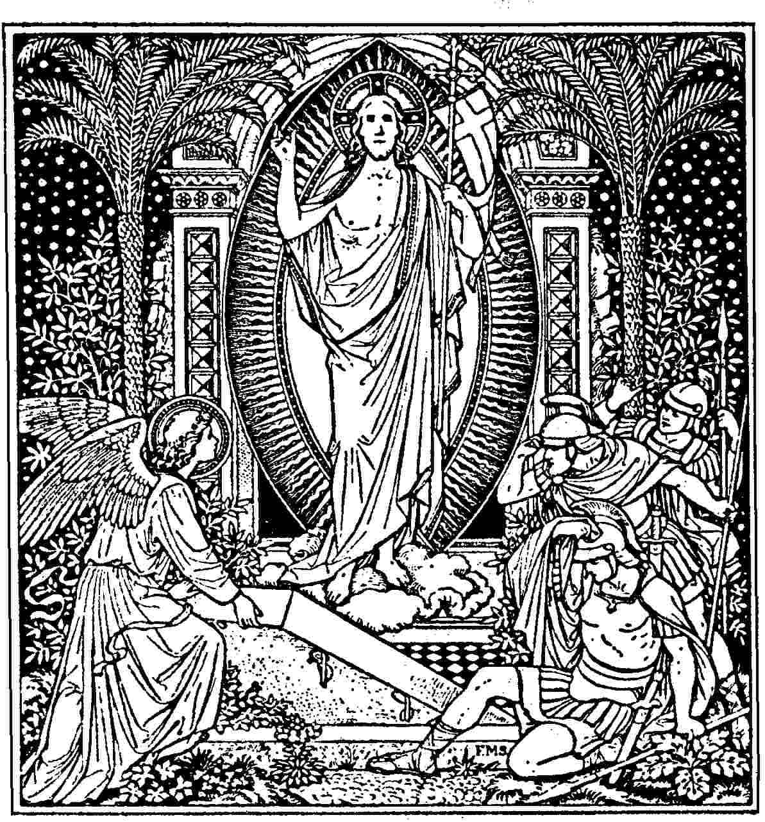

**Prayers of the People**

**In Faith, Hope and Charity let us pray for the good estate of the Catholic church.** *We give thanks for our collective health and resilience at this time. We continue to pray for all medical staff; hospitals and clinics.*  **We remember** *St. Michael and all Angels, Winnipeg; Our Diocesan prayer partners, The Territory of the People and the Diocese of Masasi; and the community of St. Michael’s Mission. For those who suffer injustice and those who work for justice and peace. We pray for the end of the conflict between Ukraine & Russia, for all the peoples of the world contending with extremism, violence and polarization. Let us pray for Canada’s Indigenous peoples; for our Earth and its living systems, and those suffering from natural and human caused disasters.* ***We also pray for our parish that we may continue as a community of faith.***

***Anglican Cycle of Prayer (April 9-15)***

**Sun**  Province of the Episcopal Church of Sudan Pray for the Peace of Jerusalem

**Mon**  The Diocese of Santiago (in Chile) – Iglesia Anglicana de Chile

**Tues** The Diocese of Santiago (in the Philippines) – Philippines

**Wed** The Diocese of Sapele – The Church of Nigeria

**Thu** The Diocese of Saskatchewan – The Anglican Church of Canada

**Fri** The Diocese of Saskatoon – The Anglican Church of Canada

**Sat** The Diocese of Sebei – The Church of the Province of Uganda

[***Diocesan Cycle of Prayer***](https://static1.squarespace.com/static/53339102e4b00c509597c34c/t/6001f5b4514b6c73056efd5b/1610741172969/Prayer+Roster+2021.pdf)

**Sun**

**Mon**

**Tues**

**Wed**

**Thurs**

**Fri**

**Sat**

**For those in special need:** Marc & Josephine,Jim Best, Mildred Fletcher, Hallam Taylor

**For continuing support:**Simon, Karen, Charles, Fr Richard Cawley, Jayne Demakos, Garrfield Du Couturier-Nichol, Diane, Réal Guérin, Tony Whitehead, Juanita Docherty-McFarlane, Ian MacLean, Vessella, Glenn Cartwright, Geraldine Doran, Desmond Murphy, Mike Curry, Tom Byford, Deirdre Hitchcox, Frances Kemp, Thomas Numann, Sandra Guillaume, Peter Iveson, RoseMary, Louise Driver, BB Gaylord, Hannah Brockow, Alexandra Belden, Anny Guillemette, Tanya

**We remember those who have died,**

**Sun** Henry Marks, Janie Macdonald, Robert Macdonald, Clara Davidson, George Aunescuic

William Campbell, Gwendoline Heapy

**Mon** Charles Brooks, Alice Broadshaw, Robert Martin, Frederick Wenham, Eric Yule,

Margaret Beede, James Baker, Patricia Lepiez

**Tues** Ellen Jackson, Henry Thorne, George Donaldson, William Crowley, Pauline McKim,

Claud Hamon, David Ariss

**Wed** Ann O’Brien, William Archibald, Ida Bring, Kaj Peterson, Paul Betts

**Thurs** Georgina May, Mary Ann Smith, Arthur Rowland

**Fri** John Knight, Stephen Dimeo, Charles Combe (Priest),Grace Elwell, George Thompson

**Sat**  **William Wright-Priest**, Edith Geddes, Florence Frost, Michael Macneil

*Please contact* [*Mother Wendy*](mailto:thurifer@hotmail.com) *or* [*Father Keith*](mailto:rector@redroof.ca) *with additions or changes to the prayer list*

**THE CHURCH OF** **ST. JOHN THE EVANGELIST**

**At the cutting edge of Tradition & a resource for the wider Church**

Founded in 1861, St. John’s is a distinct and loving community in the heart of Montreal, centered around the Anglo-Catholic Eucharistic tradition. We are committed to serving God in ‘the beauty of holiness’ through ritual, word, and music.

‘Openness to all’ is a fundamental characteristic of the parish. Such openness brings together people from a broad spectrum of origins, opinions, and life experiences, making the congregation diverse, interesting, and stimulating.

We hope that your experience in our church brings you peace and joy.

**GIVING**

**Thank you** to all those who are giving so generously to St John’s in these difficult times. Your ongoing support is much appreciated. Although we are not all meeting as a congregation in the church, the ongoing running costs of St. John’s, **$850 per day**, continue. You can give by

a) Weekly Offering Envelopes,

b) PAR (Pre-authorized Remittance)

c) Canada Helps on our website [**www.redroof.ca**](http://www.redroof.ca)

d)  **E transfers. The Parish is now set up to accept E transfers for donations. Follow your banking institutions instructions and go to** [**office@redroof.ca**](mailto:office@redroof.ca)

**PROMENADE DES ARTISTES**

137 President Kennedy Avenue

Montreal (Quebec) H2X 3P6

redroof.mtl**

 **office@redroof.ca     514-288-4428**[**www.redroof.ca**](http://www.redroof.ca/)

**THE REV’D CANON KEITH A. SCHMIDT, RECTOR**

[**rector@redroof.ca**](mailto:rector@redroof.ca)514-717-4930 (Cell)  514-288-6130 (Study)

**Associate Priests:**The Rev’d Wendy H. Telfer - [thurifer@hotmail.com](mailto:thurifer@hotmail.com) - 514-506-2386

The Rev’d Marc-Philippe Vincent – [marc-philippe.vincent@redroof.ca](mailto:marc-philippe.vincent@redroof.ca) - 514-915-2067

**Assistant Curate:** The Rev’d Susan Searle - [inguz@sympatico.ca –](mailto:inguz@sympatico.ca%20-) 438-823-2106.

**Honorary Assistant:** The Rev’d Dr. Richard  Cawley, **Honorary Associate**: Captain the Rev’d Alain Brosseau

**Assistant Priest Emeritus**: The Rev’d Canon Dr. J. Simons

**Director of Music:**Dr Federico Andreoni

**Wardens:** Geoffrey Little and Sara Bohl Pistolesi